|  |
| --- |
| **VERZEO** |
| **AZURE MAJOR PROJECT** |
| **Done By:- ASHWITH**  **Email id:-** [**ashwith2411@gmail.com**](mailto:ashwith2411@gmail.com) |
|  |

**Problem Statement**

Understanding the Azure Compliance

**DESCRIPTION**

XYZ Corporation is a globally distributed firm. They have their main office in the Central US with another branch office in the EAST US. Currently,

they are working on a project which require higher availability so the company has decided that all the servers should be a part of higher

Availability set in the headquarter regions as they don’t want to split the servers across regions. Also, they have location restrictions for Central

US. But, they also wanted to ensure that every resource in the environment should be locked so that unnecessary deletion won't happen. They

newly hired two new member User01 and User02 who are appointed as Global Administrator and Owner for the respective subscription to take

care of their infrastructure.

Background of the problem statement:

As an organization, they are open to suggestions and are currently evaluating Azure as a deployment platform. To prepare for the deployment of

servers they decided to choose IaaS Standard_B1ms and also they have the location restrictions to Central US along with all the servers which

are going to be deployed and must belong to the same place along with the same size. In addition, since for the initial phase of the project the two

servers which are going to be deployed should be highly available within the Azure Data Centre. Also, they wanted to ensure that no other user’s

except the Global Administrators wont edit and make any changes to their resources so they need to apply Locks. Also if any new user is joining

they should be provided with reader roles only for the subscription. Server credentials are essential so need to be stored in a key vault solution.

Also, they have a storage account in Central US which can be only accessed with the respective client IP Address.

After the setup, the deployment team ensures that Azure Compliance is met.

**Following requirements should be met:**

1. Create two users User01 and User02 in the Azure AD and give them Global Admin Access.
2. Both User 01 and User 02 are owners for the subscription.
3. Create User03 and provide it the reader access. Can this User create the VM in the Subscription?
4. Create two servers in the Main Office and place them in one Availability Set.
5. Create a policy for the VM Size and Location.
6. Validate the policy after its creation.
7. Create and apply the “Lock” at the Resource Group Level so that all the corresponding resources will be Locked.
8. Create Storage Account and Give access to the respective Client IP Address only.
9. Understand the Difference Between Availability Set and Zone.

**The Process-**

**1.Create two users User01 and User02 in the Azure AD and give them Global Admin Access.**

Go to Azure Portal and Select Azure Active Directory.

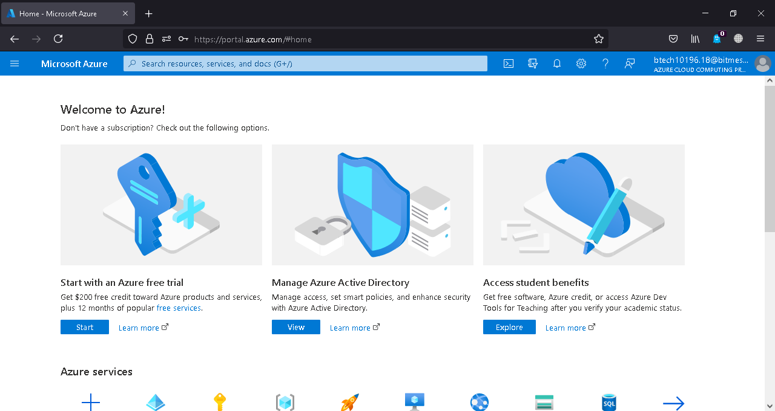

Click on Add and Select User to Create User01.

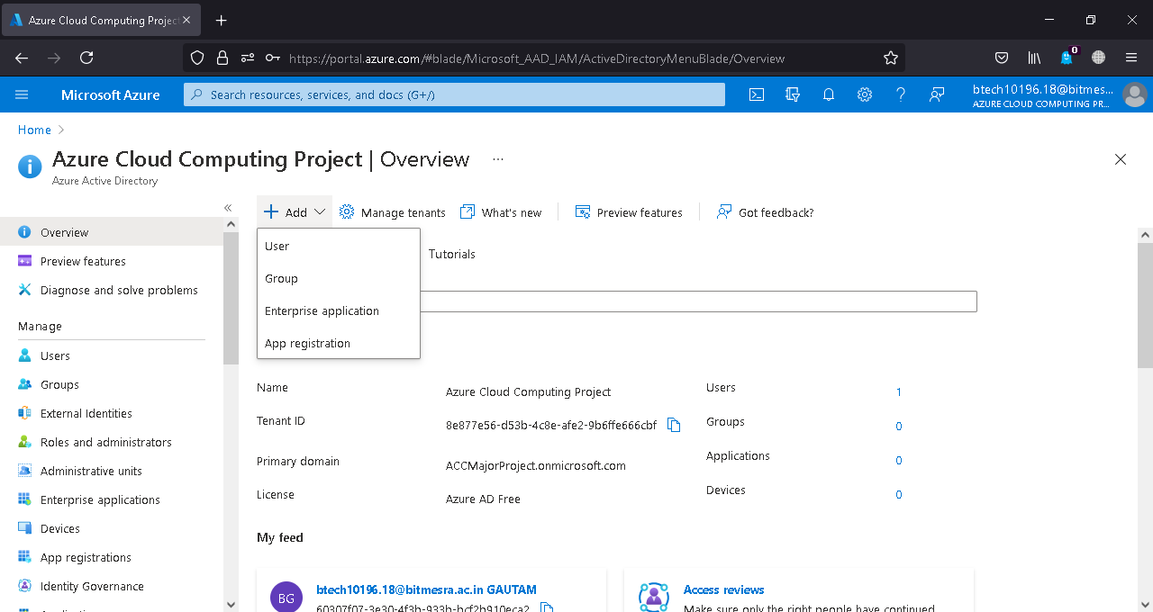

Fill the Details such as username,password etc.

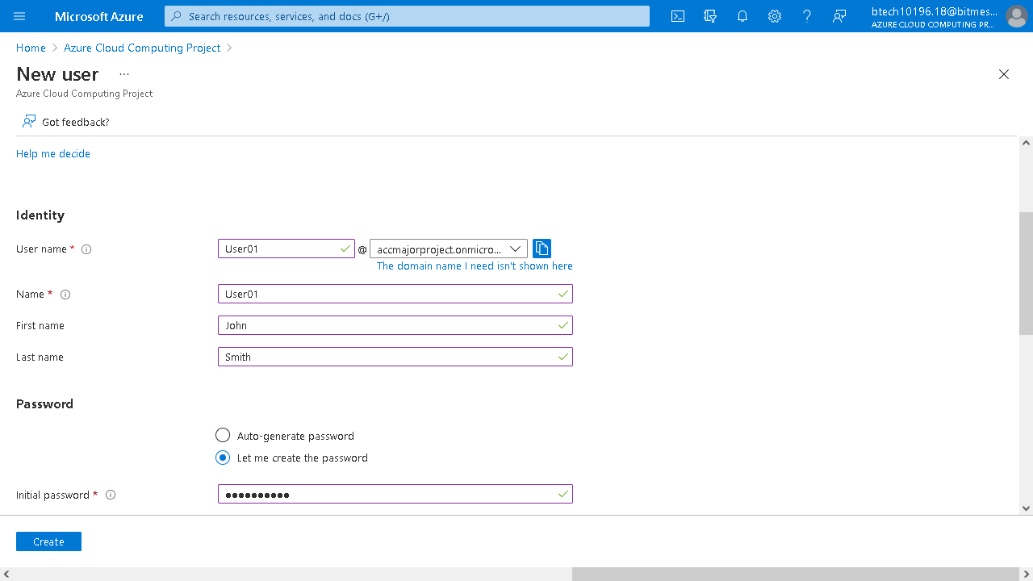

Click on Roles and Select Global Administrator.

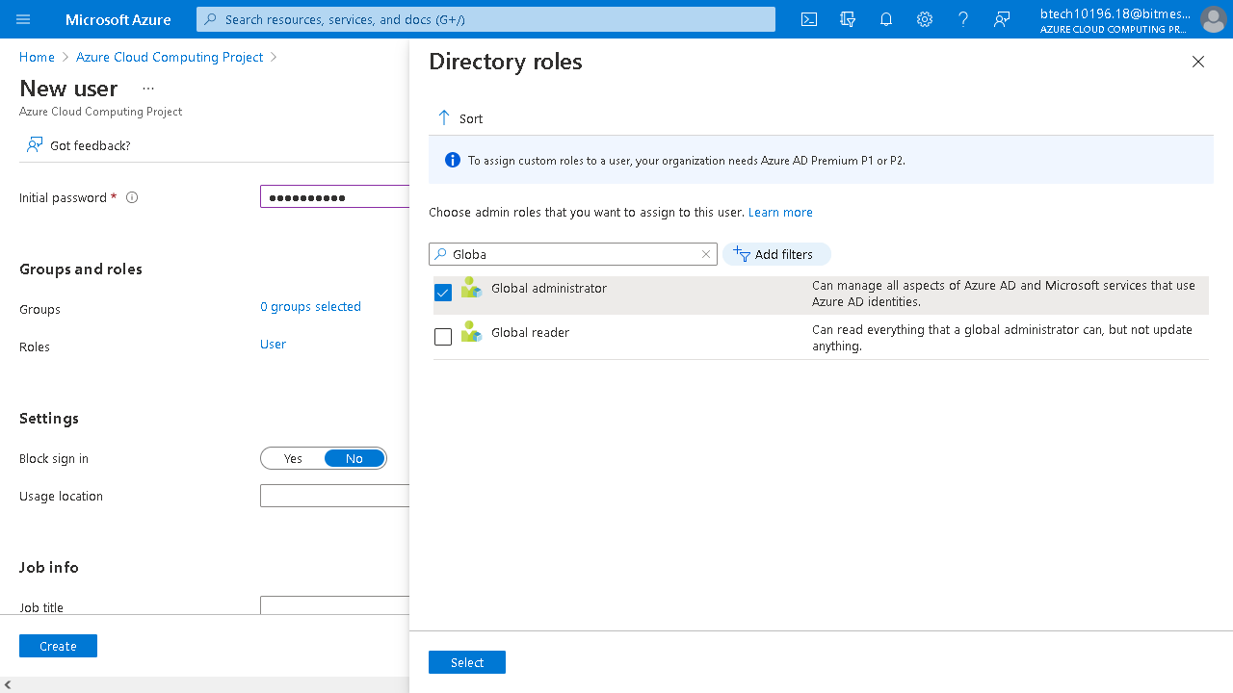

Fill the other details and click Create.

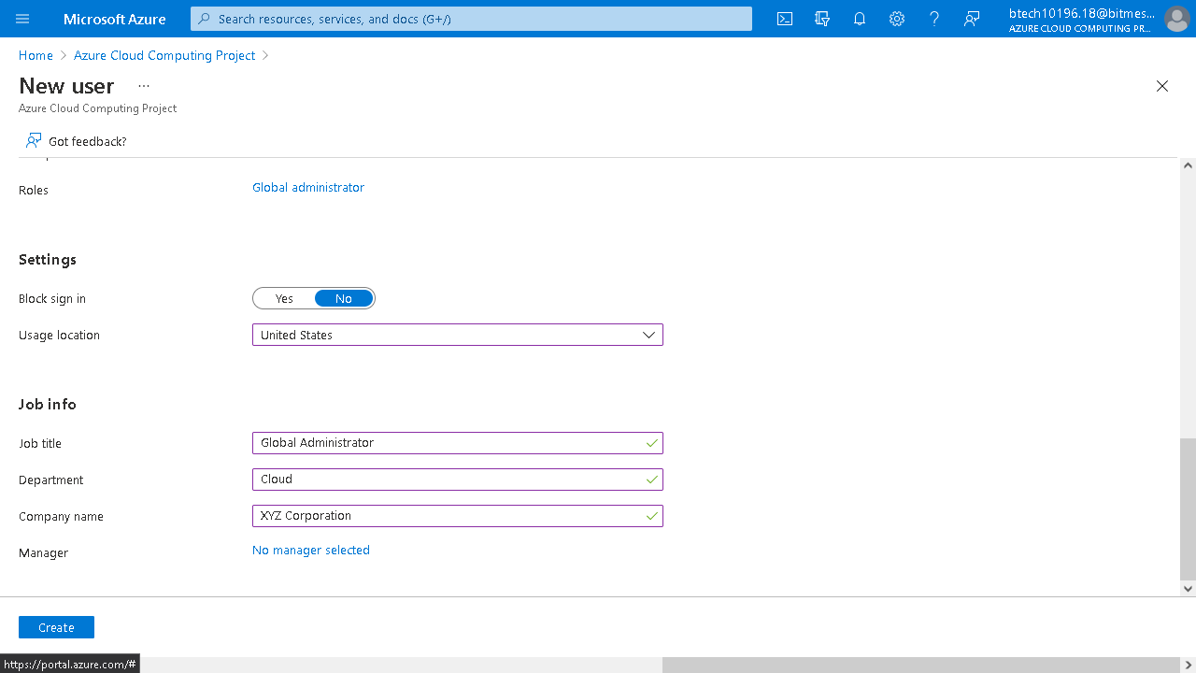

Wait for the Notification to Shows Up.

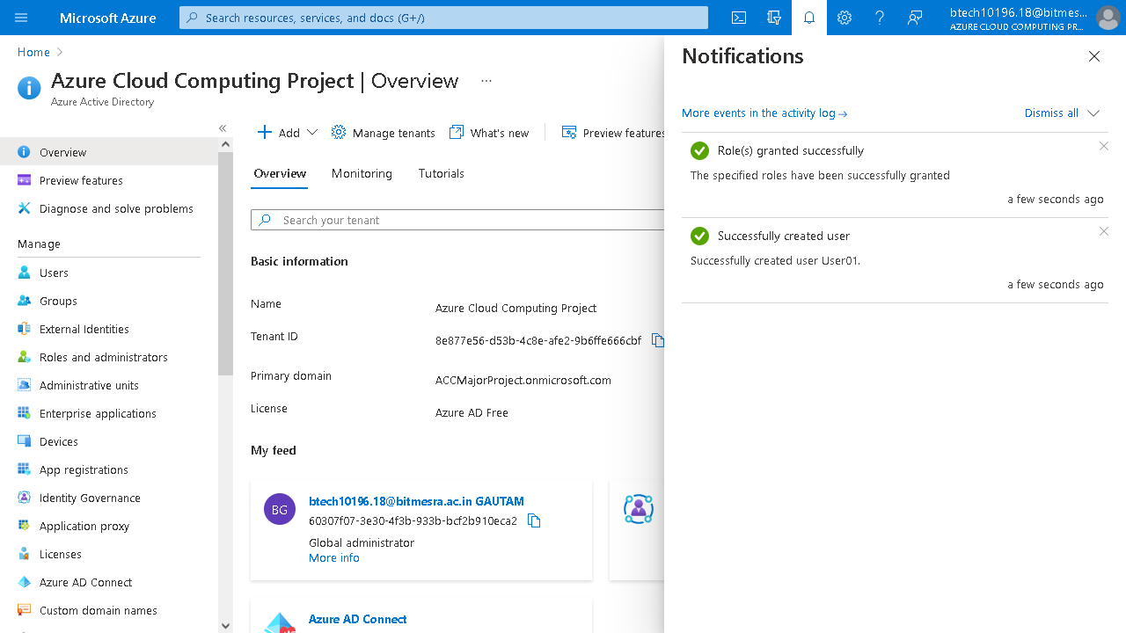

Similarly Create User02 While repeating the same steps.

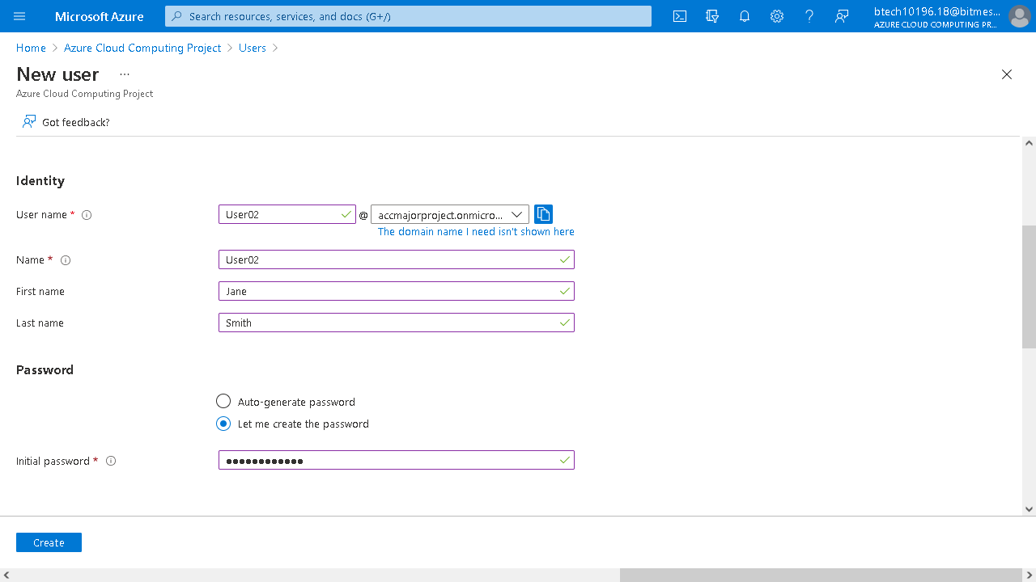

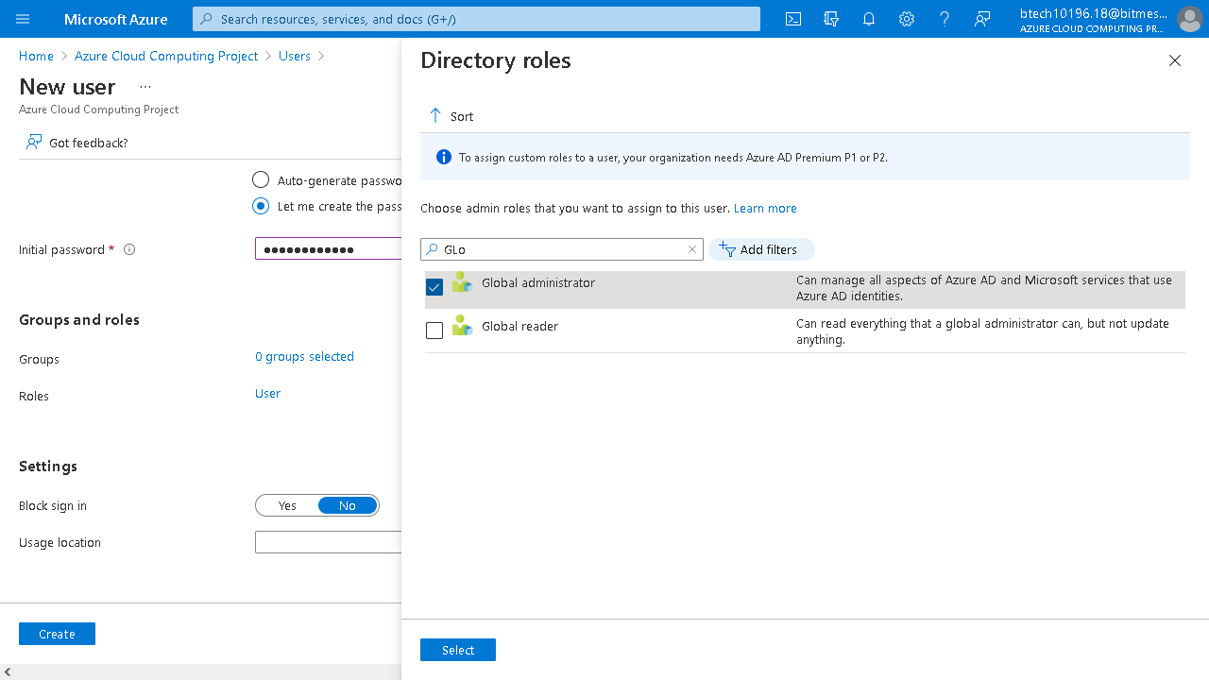

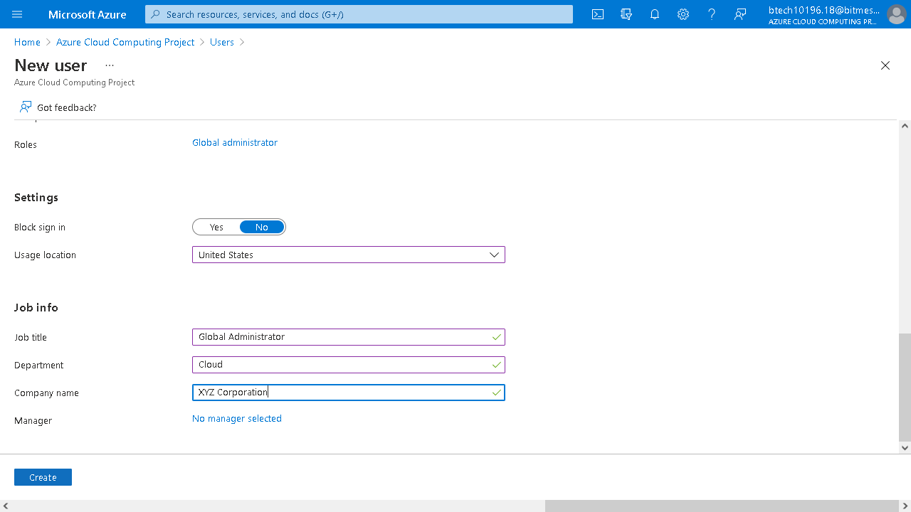

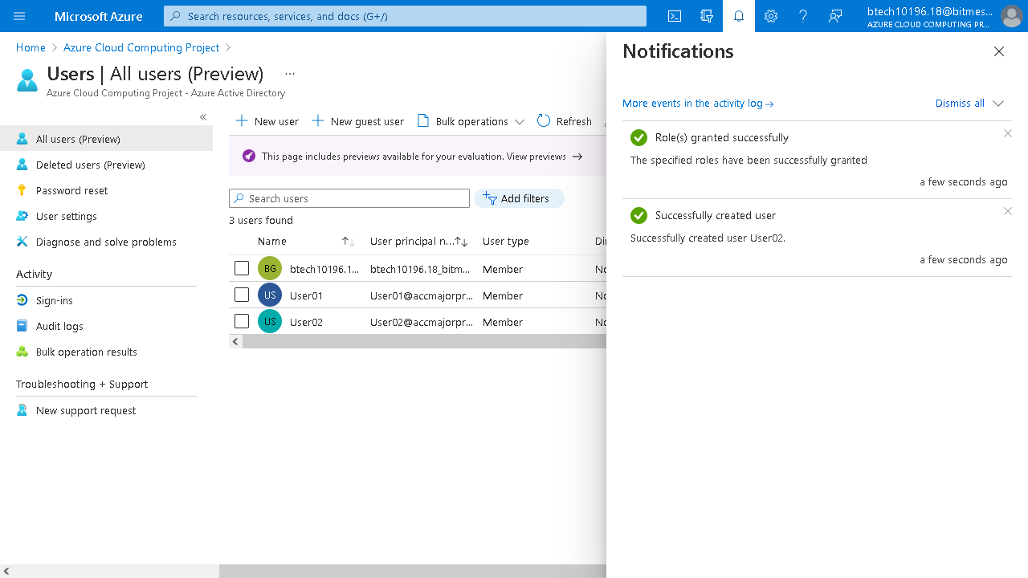

**2.Both User 01 and User 02 are owners for the subscription.**

Go to Azure Portal and Select Subscriptions and click on your subscription.

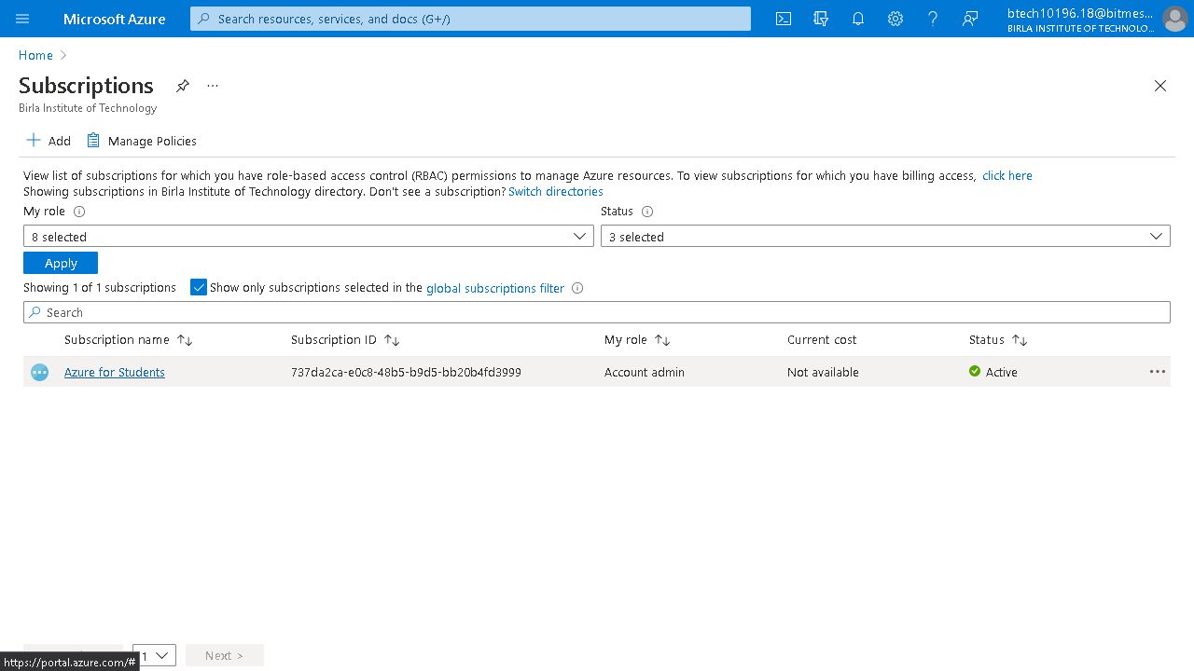

Go to Access Control(IAM) and click add.

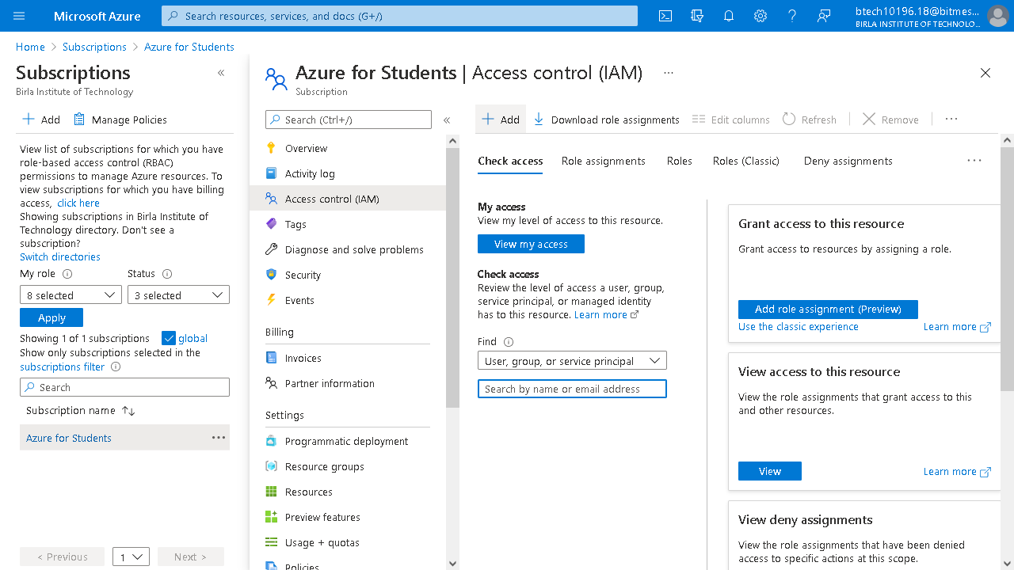

Select Add role assignment.

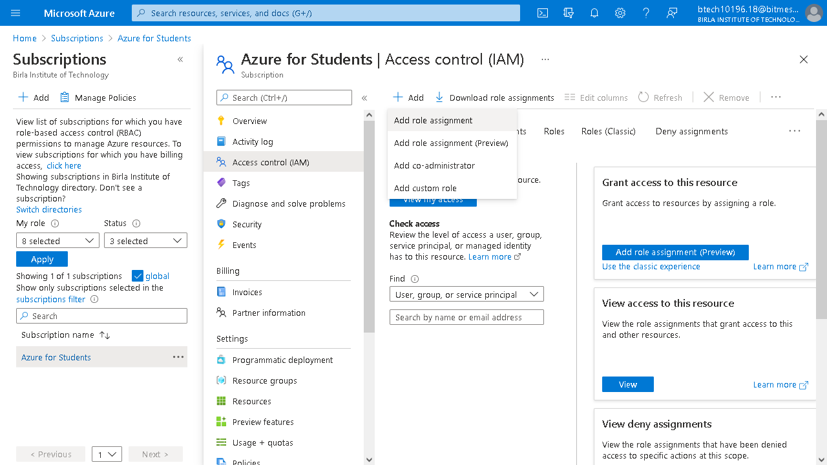

Select Owner as Role and enter details of the two users.

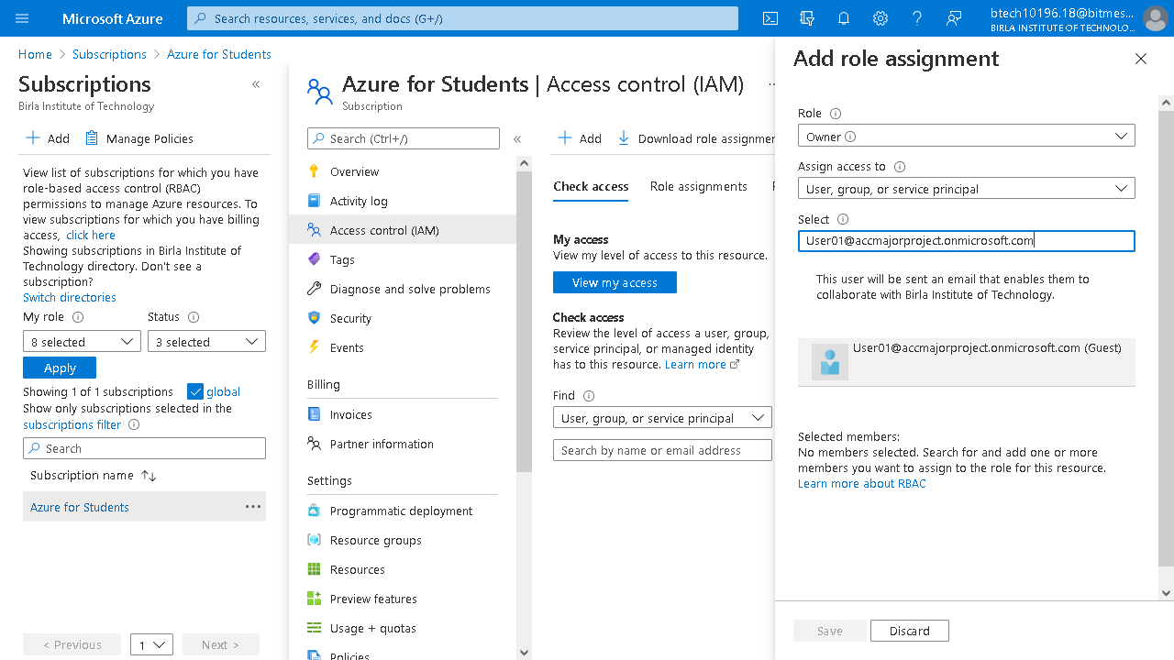

Click Save.

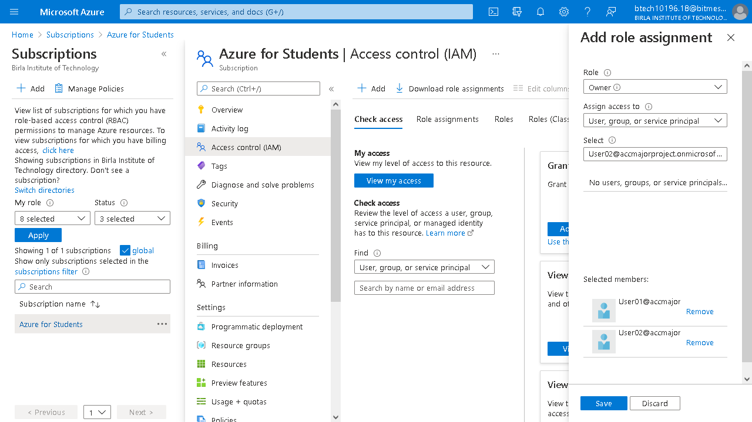

Wait For the notification to Pop Up.

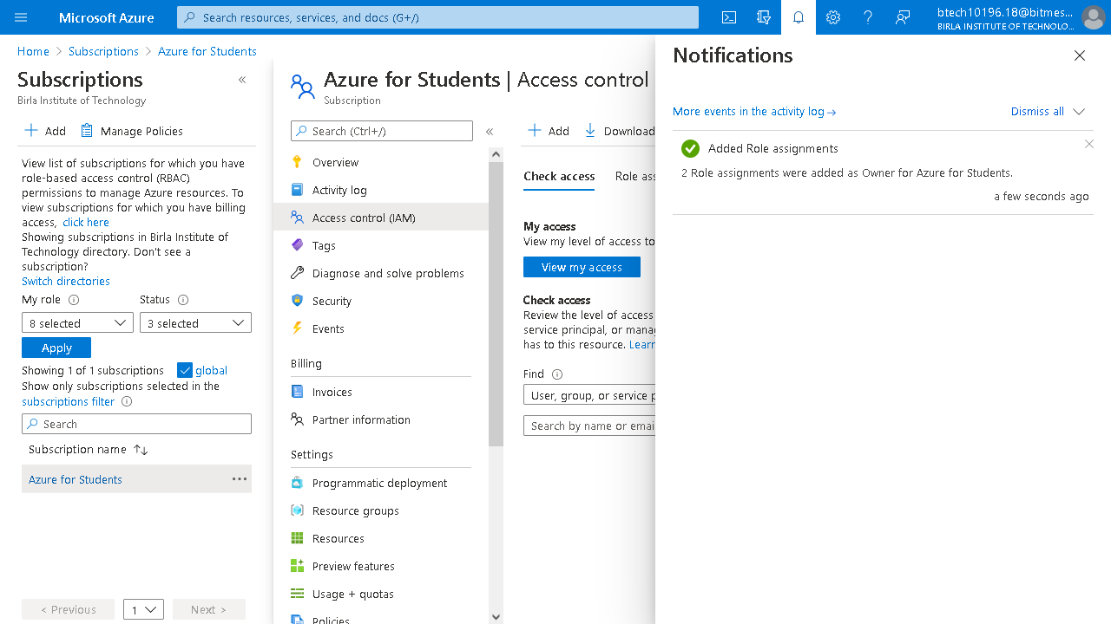

**3.Create User03 and provide it the reader access. Can this User create the VM in the Subscription?**

Create a New User named User03.

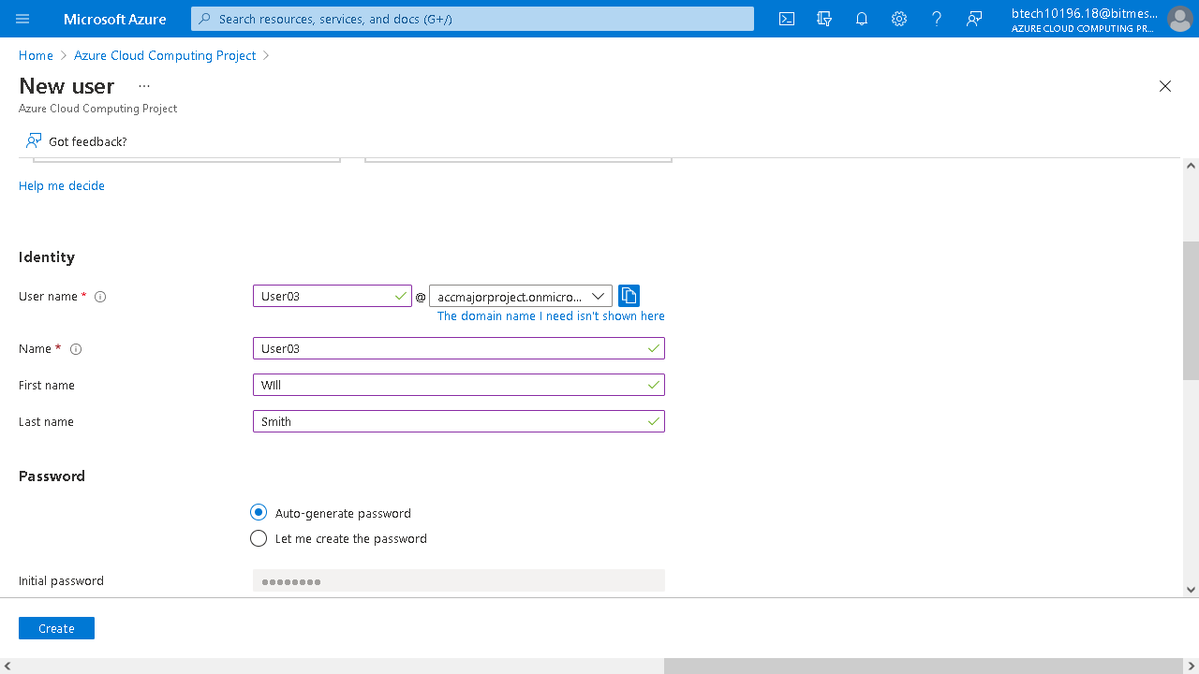

In Roles Select Global Reader Role.

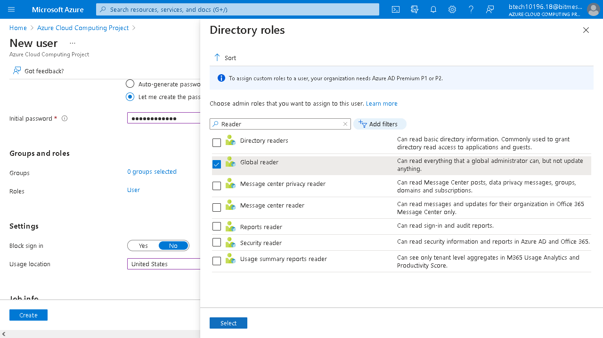

Fill the rest of the details and click create.

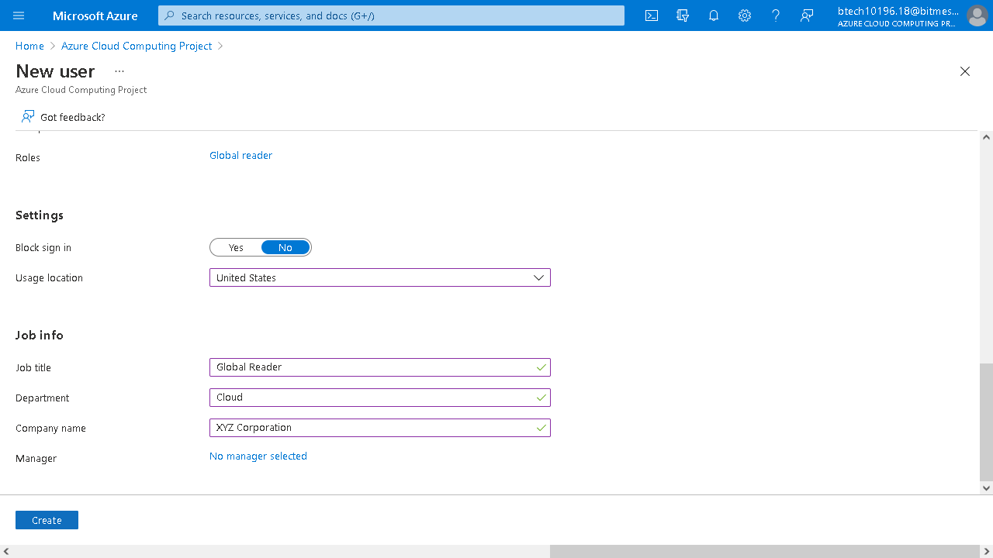

Wait for the notification to Pop up

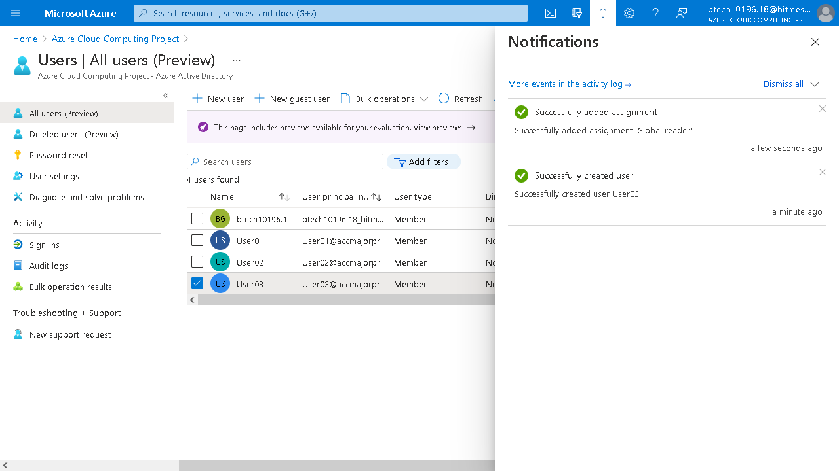

The Portal Will not Let User03 create a VM since it only has a reader role.

**4.Create two servers in the Main Office and place them in one Availability Set.**

Log Back Into Global Admin Account and Click Create a virtual machine to Create the Server.

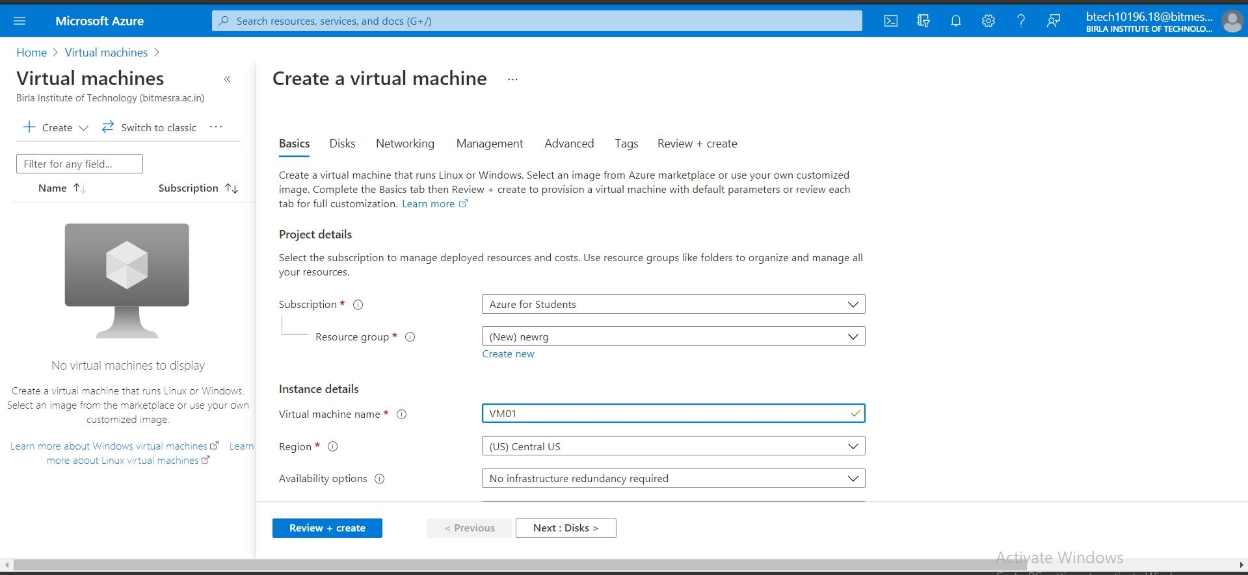

Fill the Details and Place it in the Availability Set standard_B1ms.

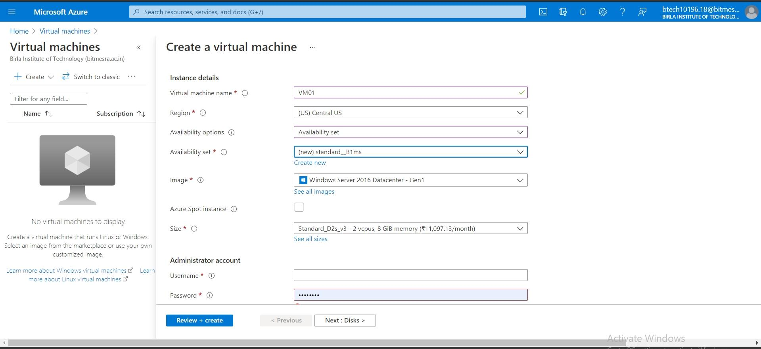

Fill in the rest of the details and click Create.

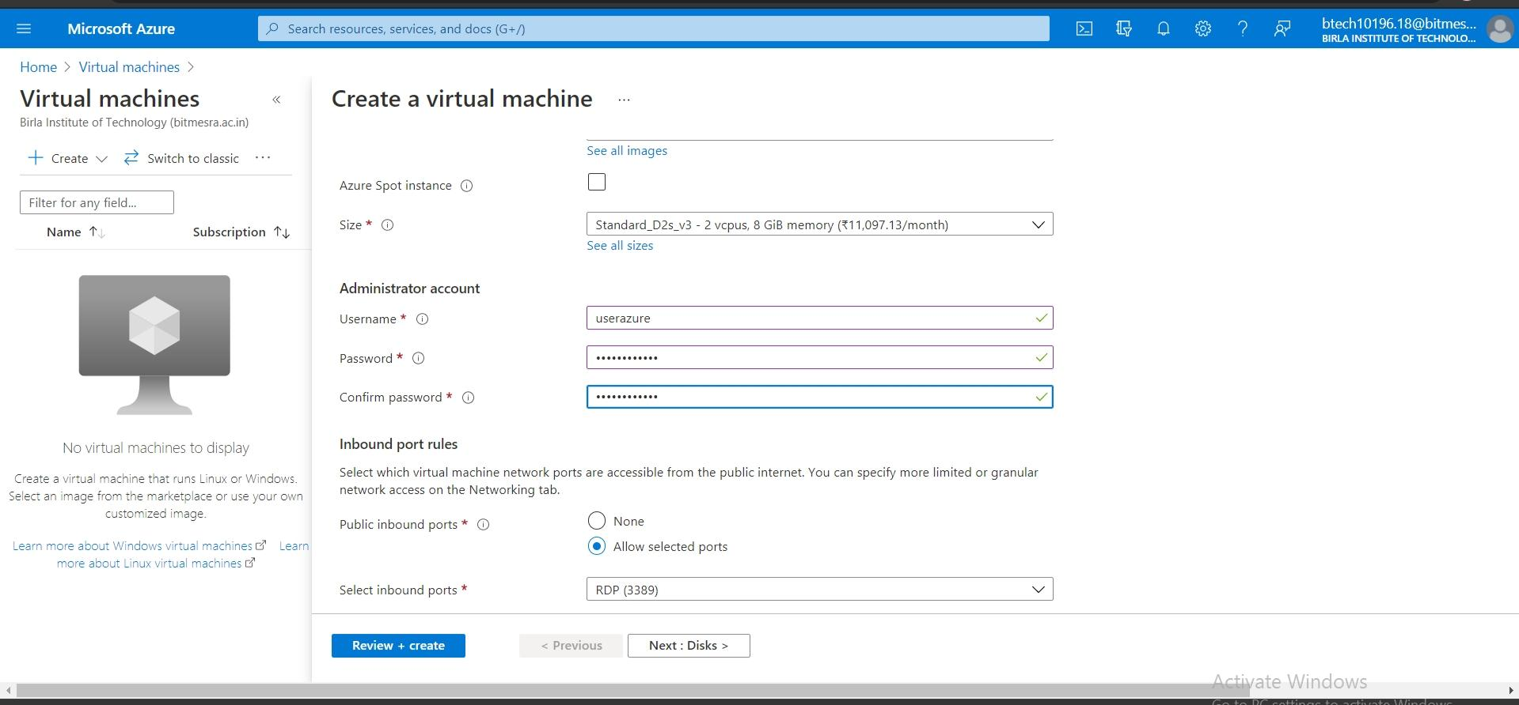

Wait for Notification to Pop up.

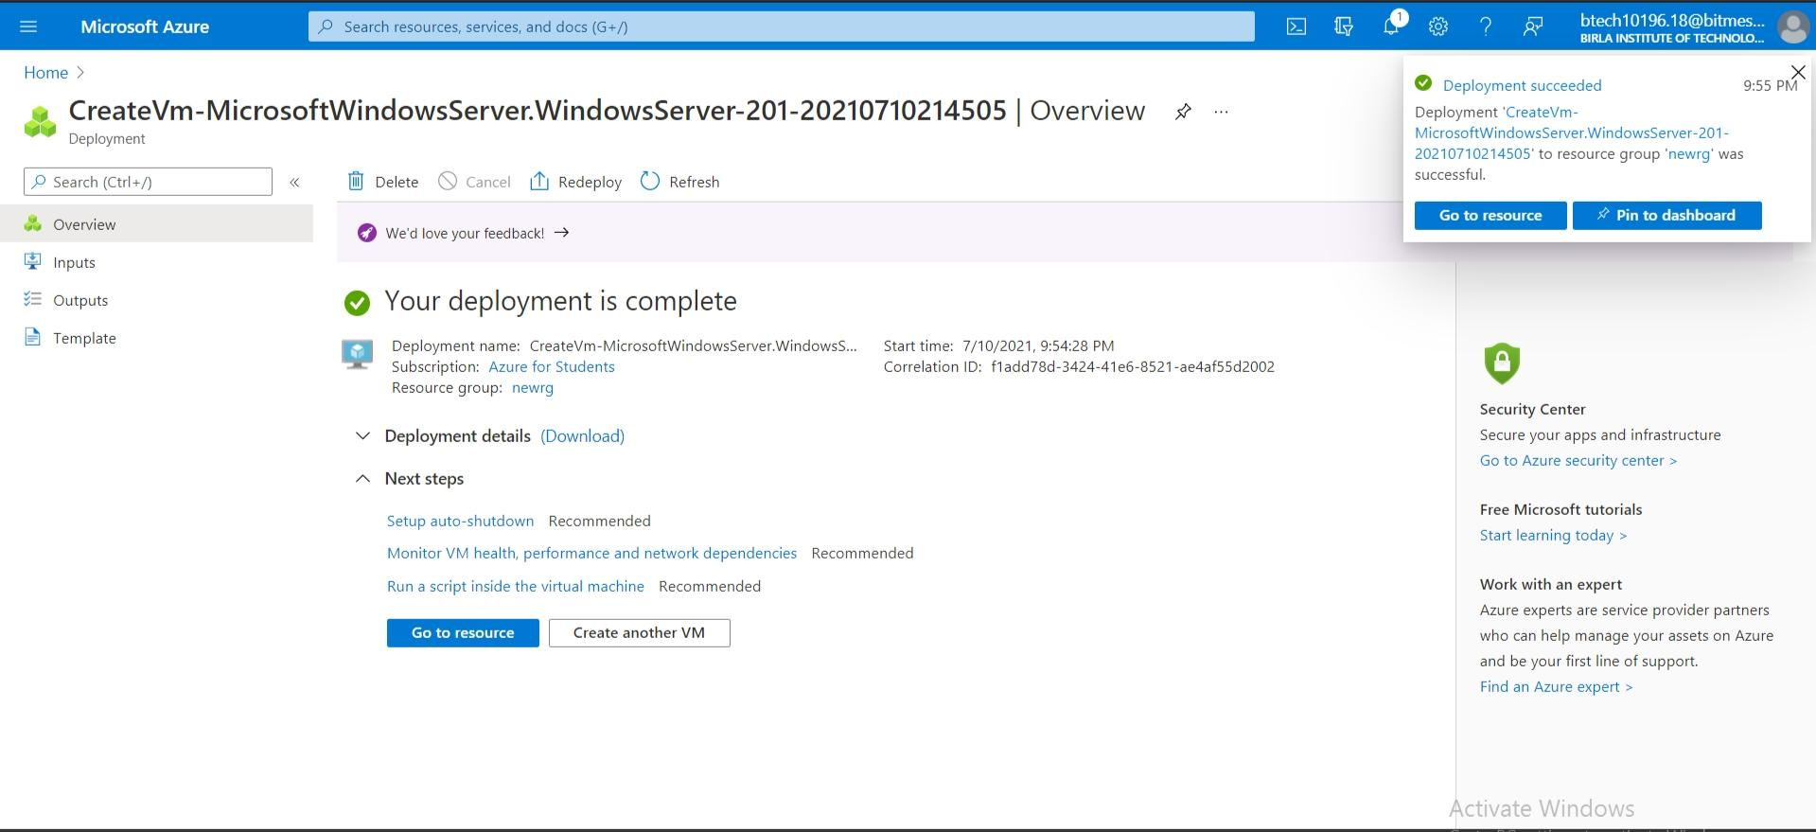

Similarly Create the Second VM Server.

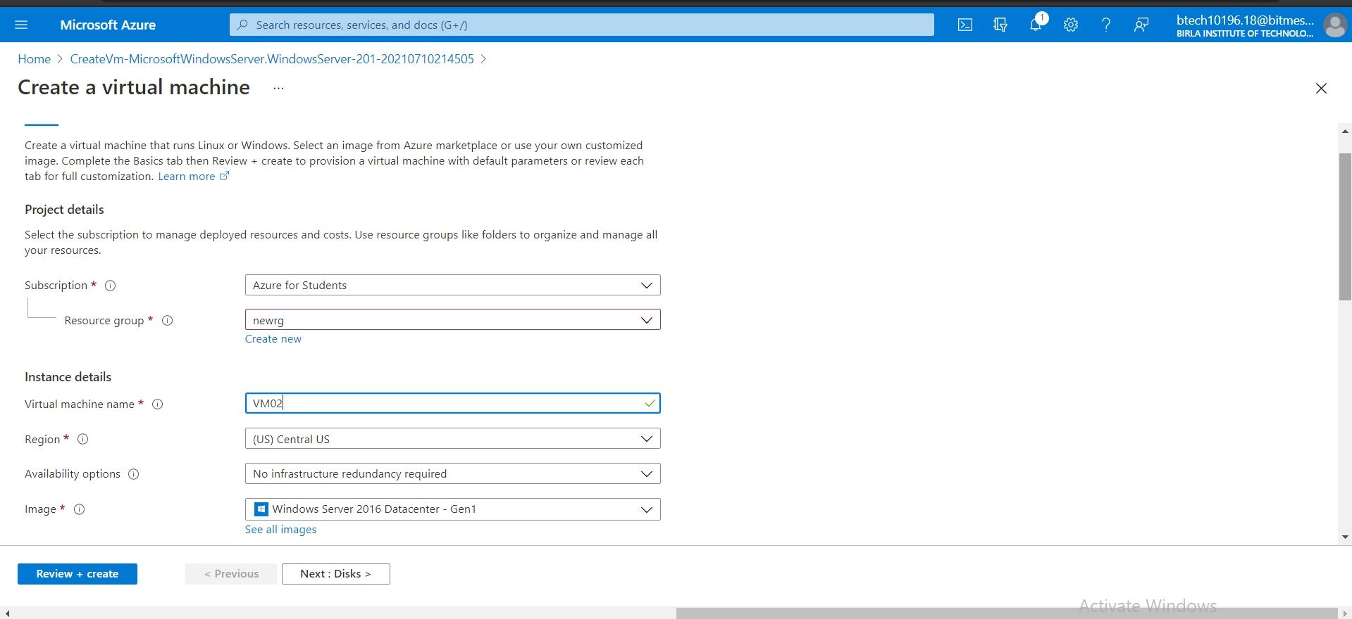

Select the same Availability set as the first server i.e. standard_B1ms.

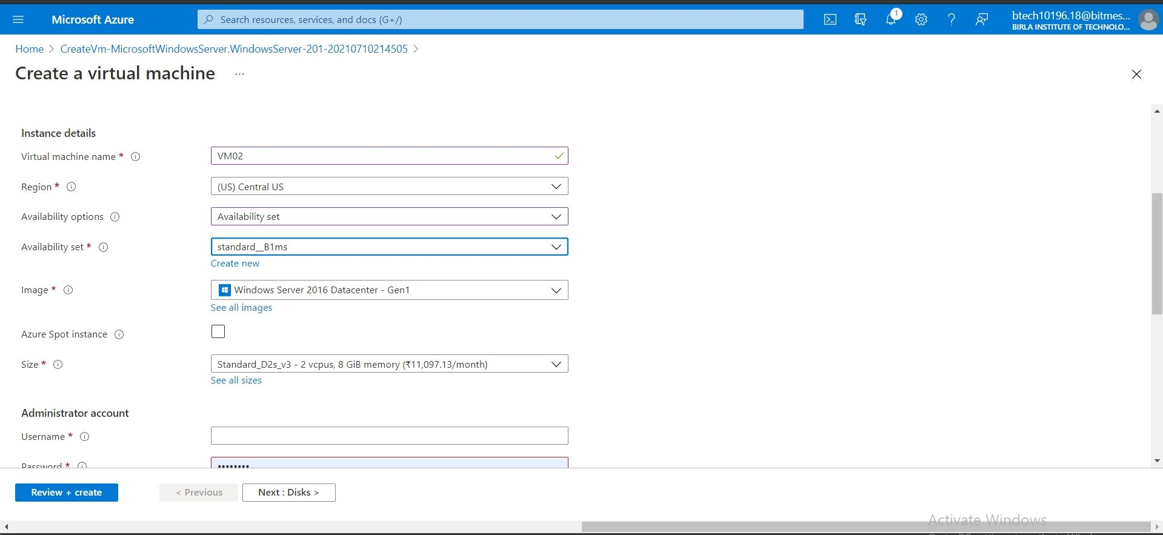

Fill in the rest of the details and click create.

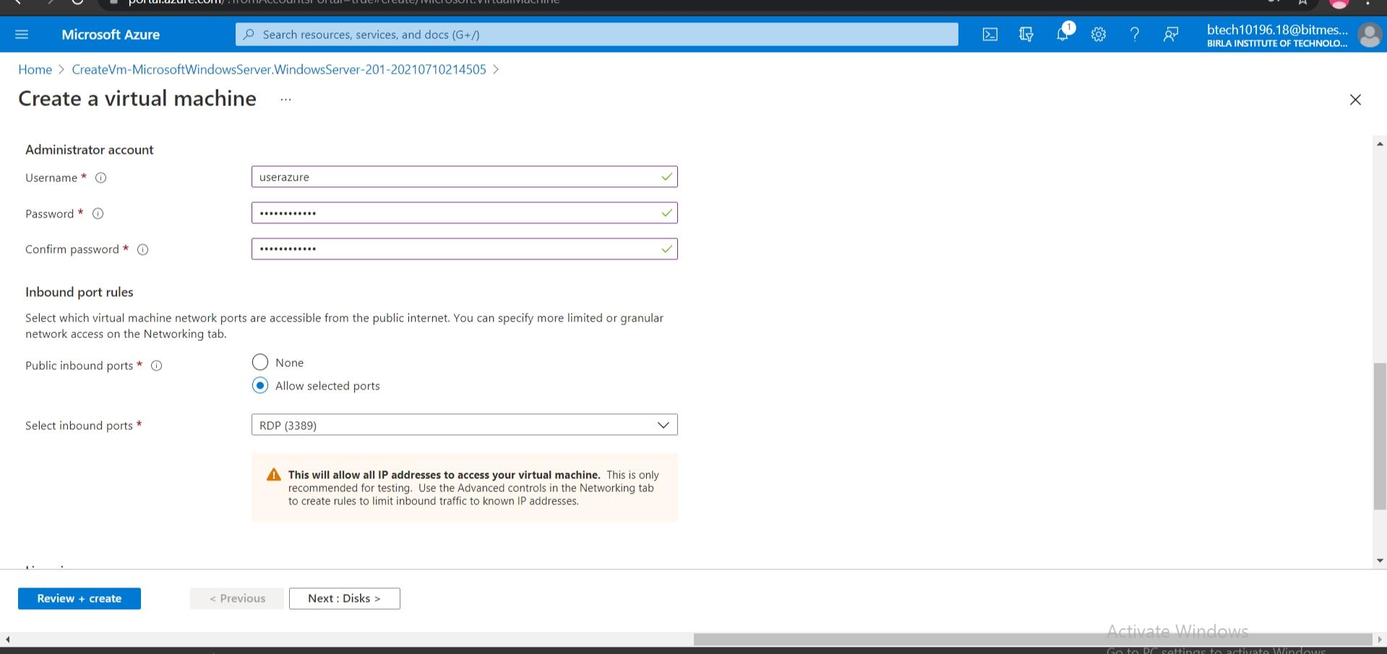

Wait for Notification.

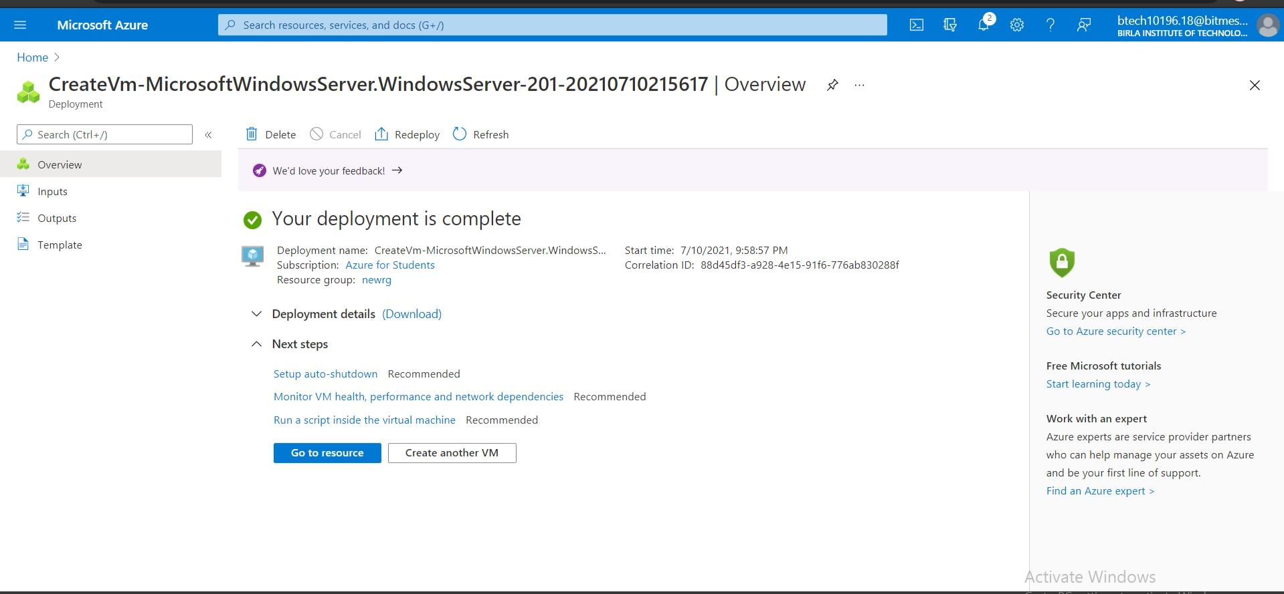

Check if they are in Same Availability Set or not.

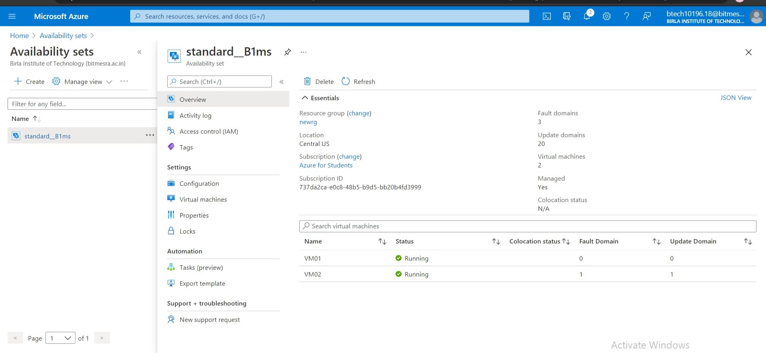

**5.Create a policy for the VM Size and Location.**

Go to Azure Portal and Select Policy and Click on Definitions and the Policy Definition.

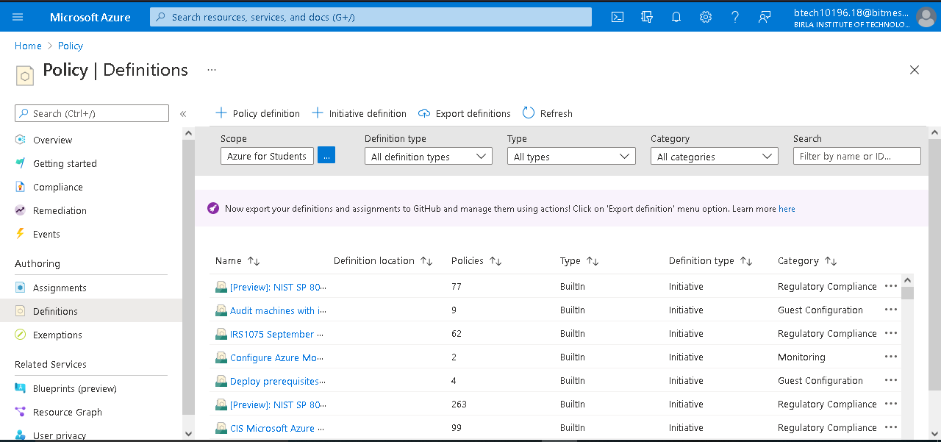

Fill in the Details for the Policy.

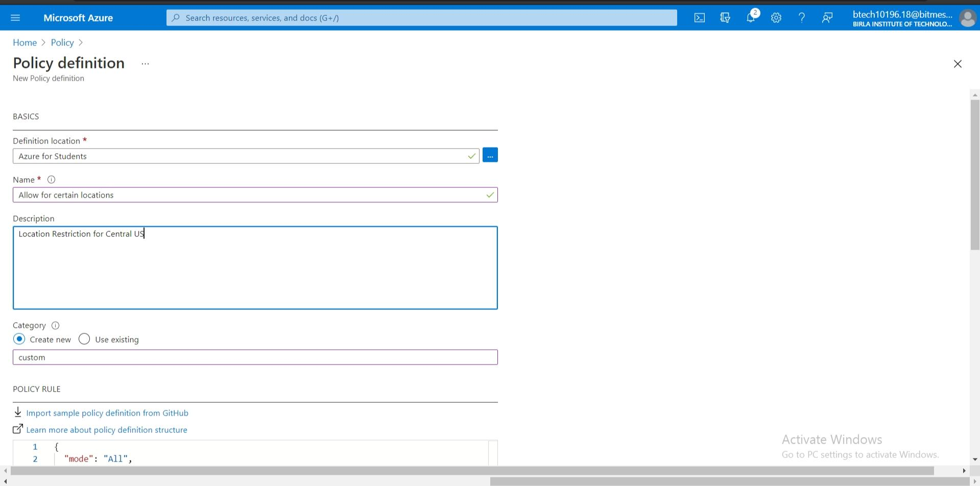

Make Necessary Changes to the Code according to policy requirements and Select Assign to select which resources or subscription this policy will apply to.

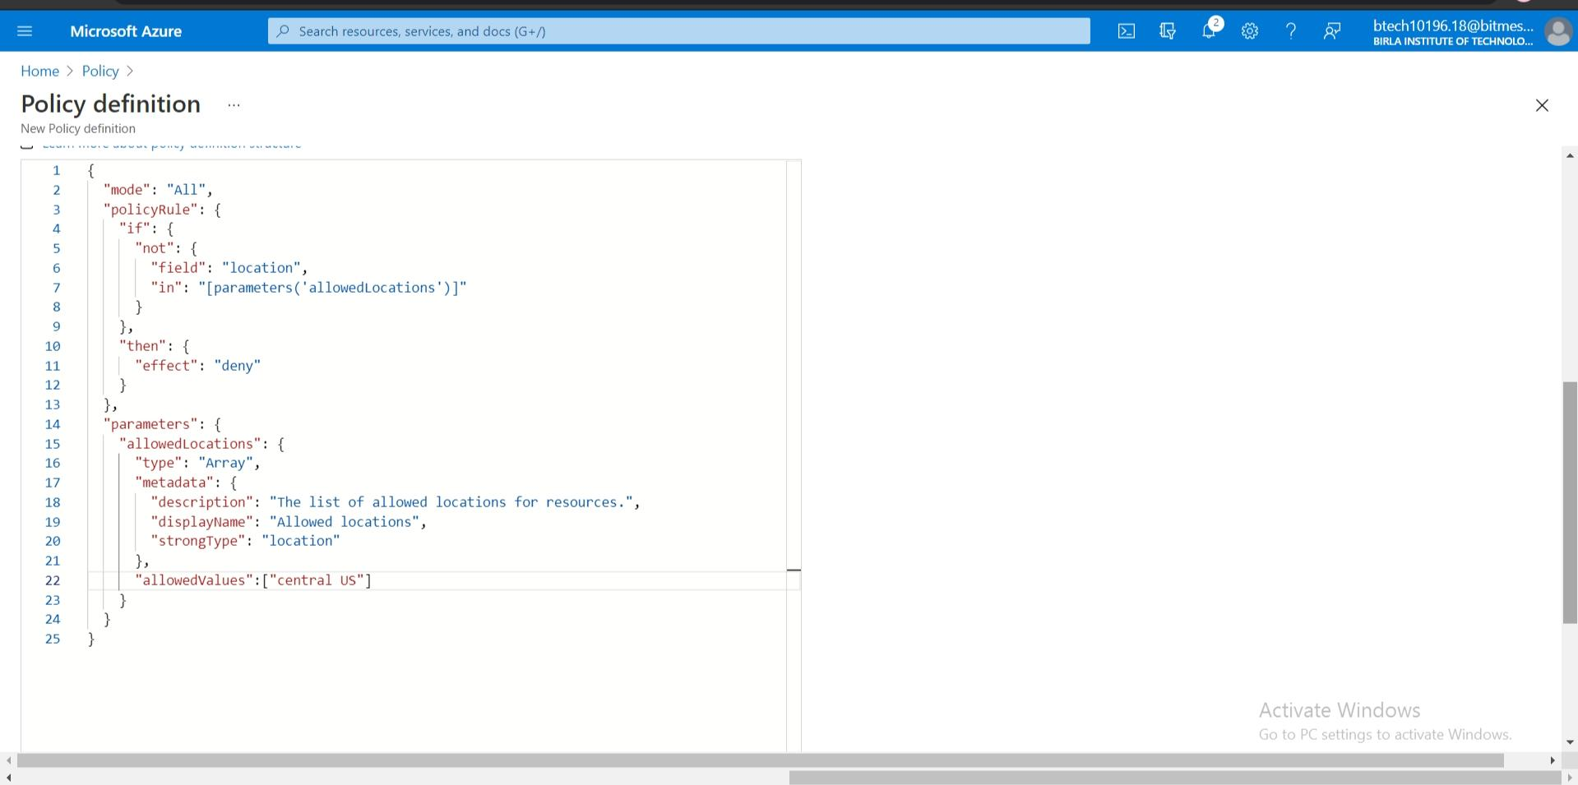

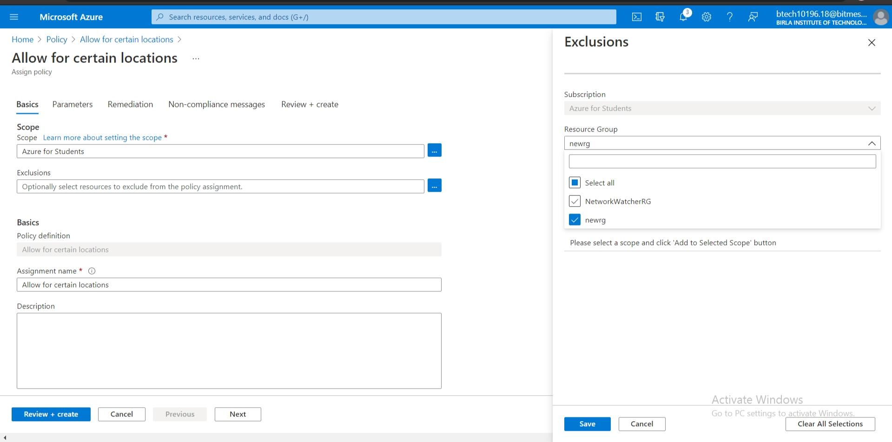

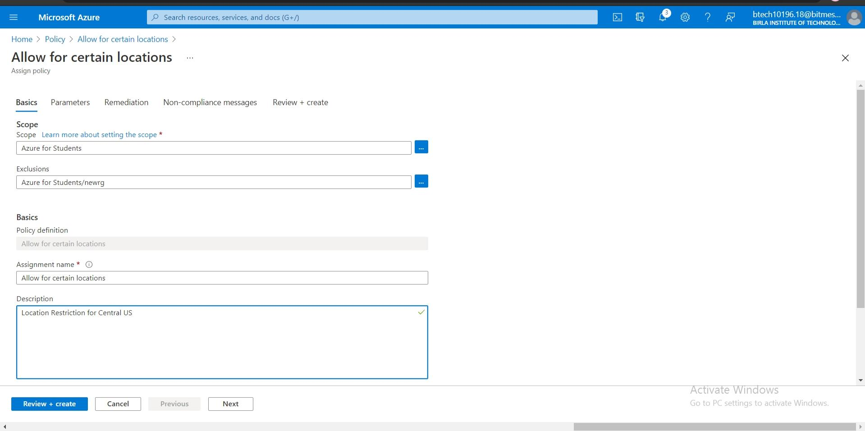

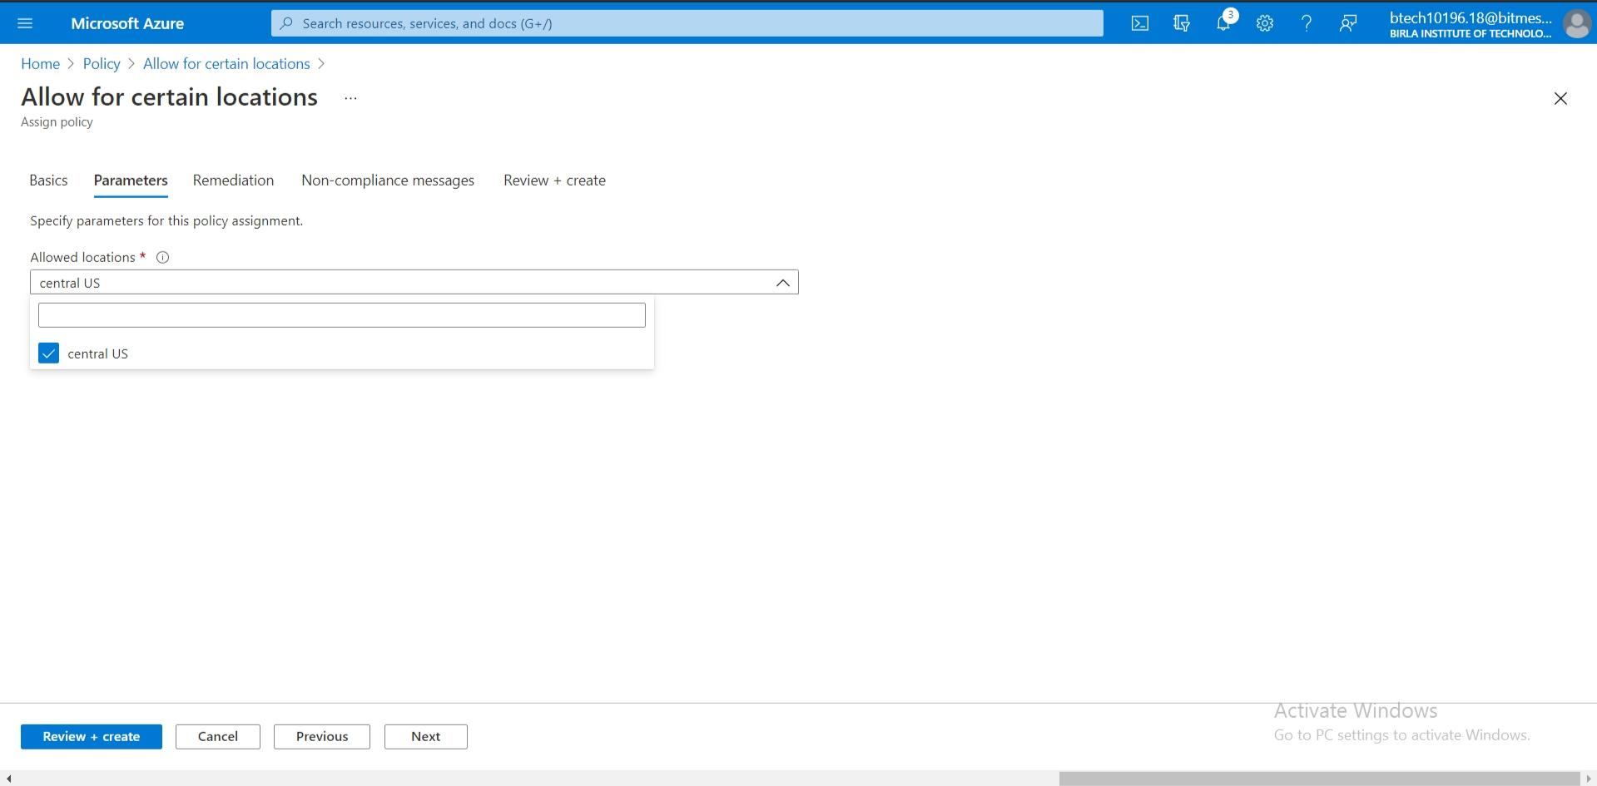

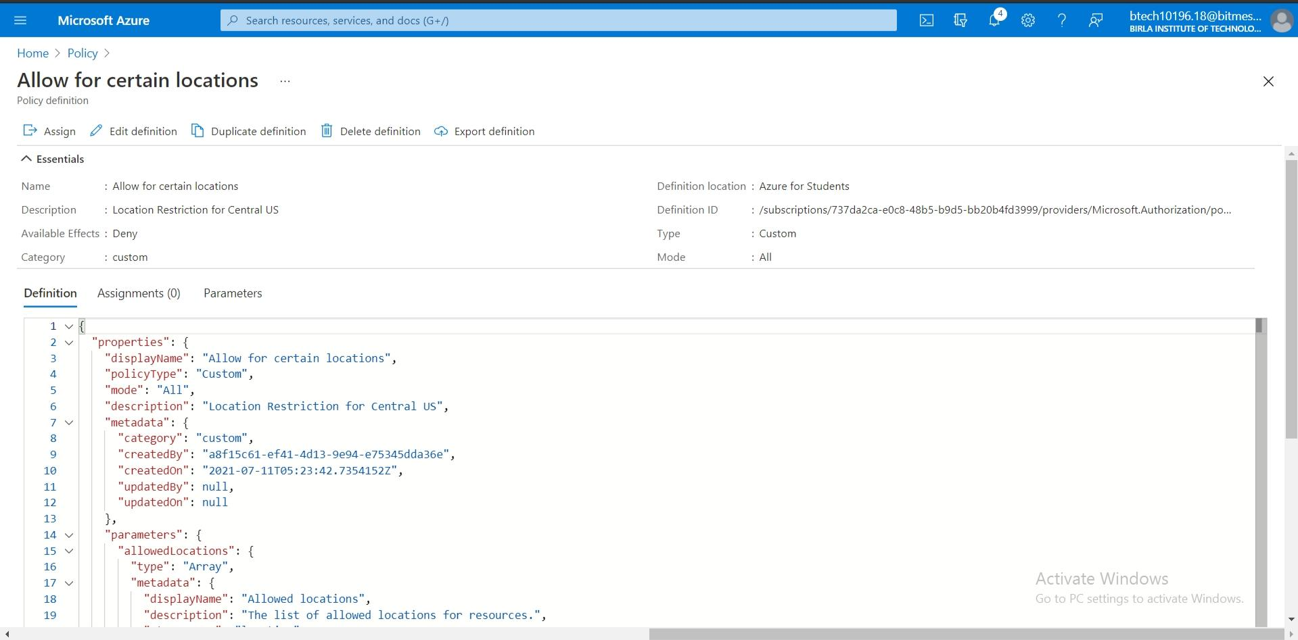

**6.Validate the policy after its creation.**

Try to Create a Resource Group in any region other than the Central US.

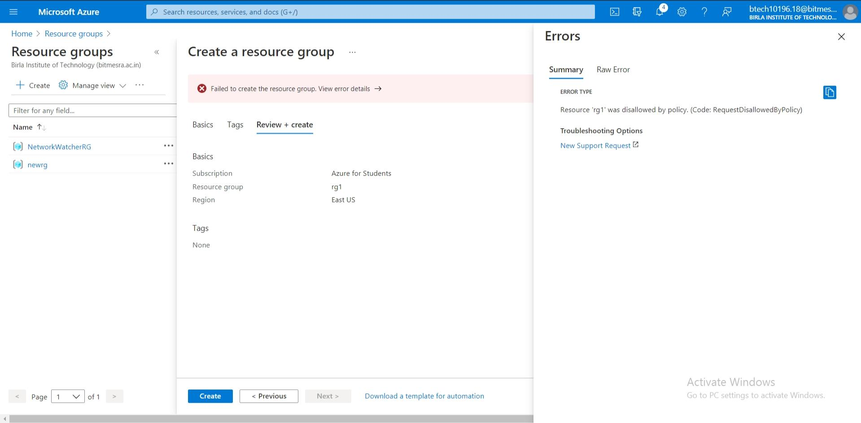

Try To Create a New VM in a Region other than the Central US.

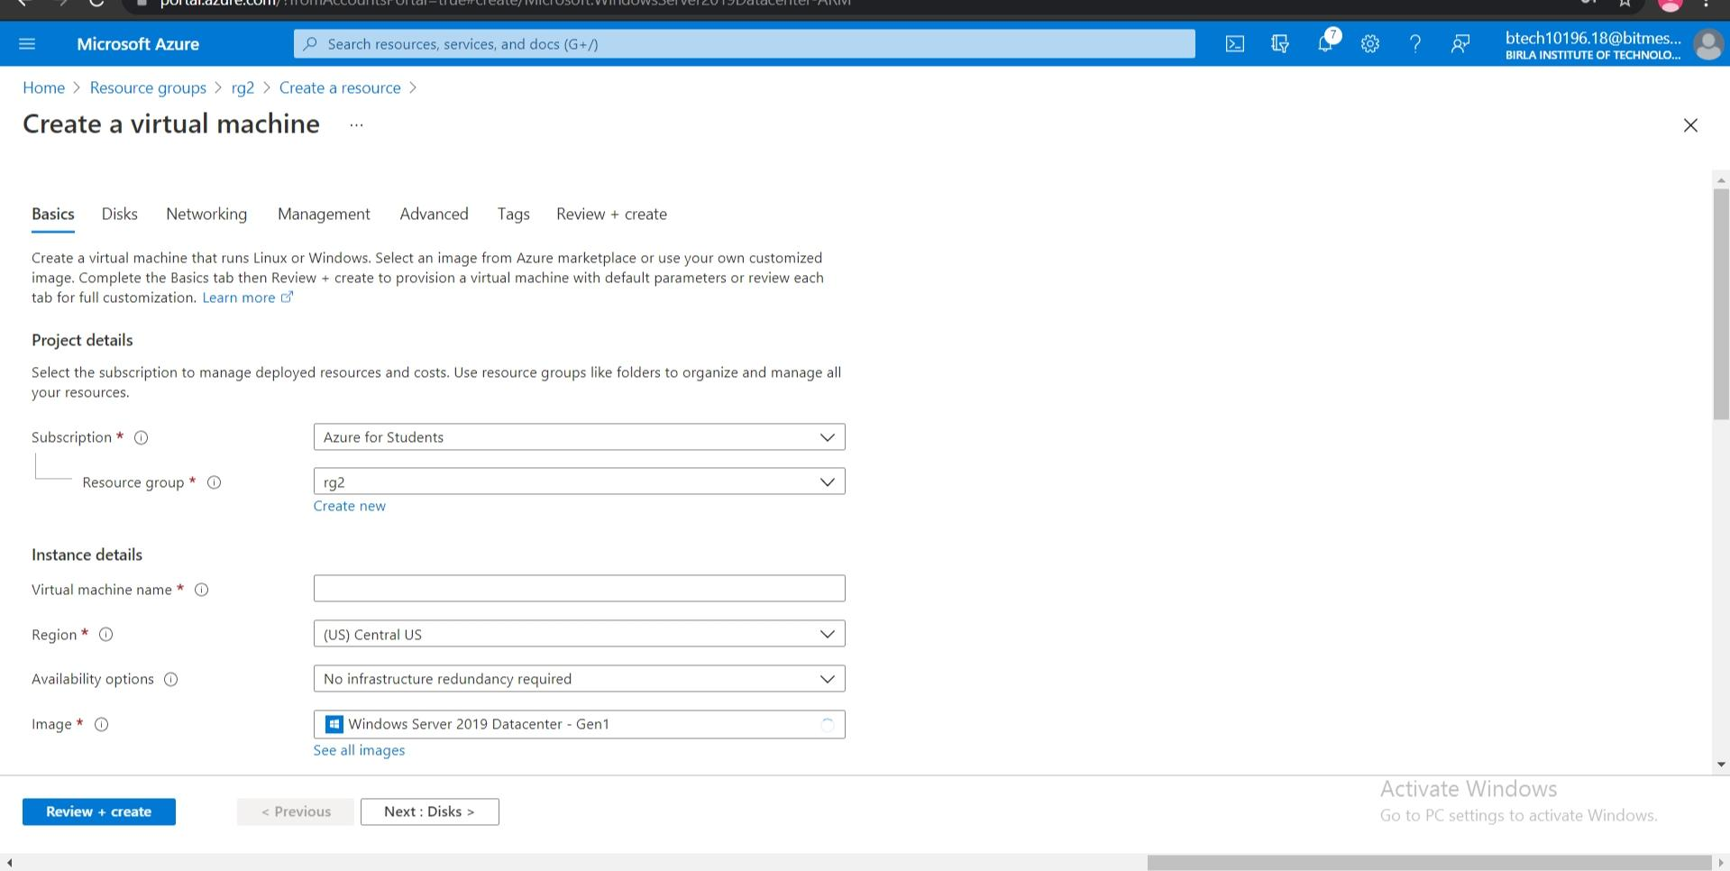

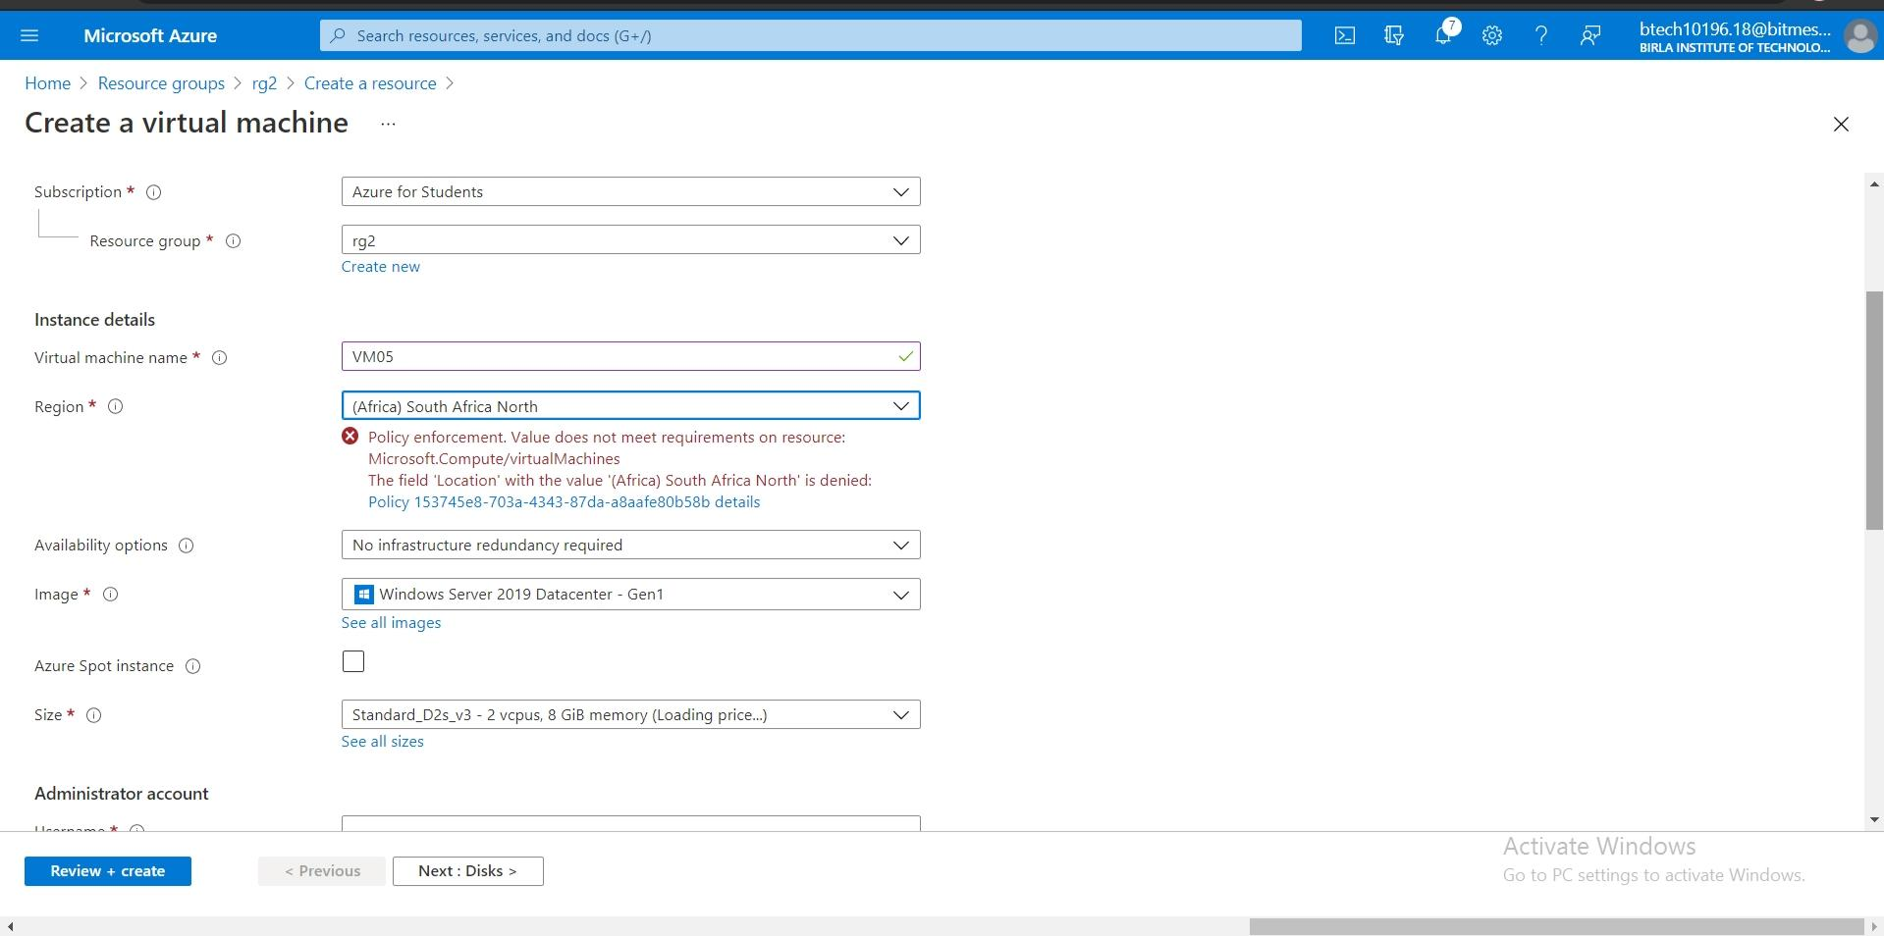

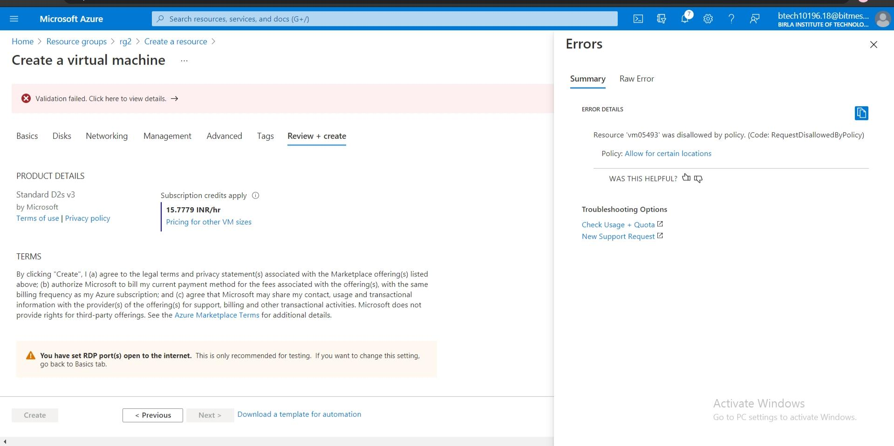

**7.Create and apply the “Lock” at the Resource Group Level so that all the corresponding resources will be Locked.**

Go to Azure Portal and Select Resource Groups and click on a resource group.

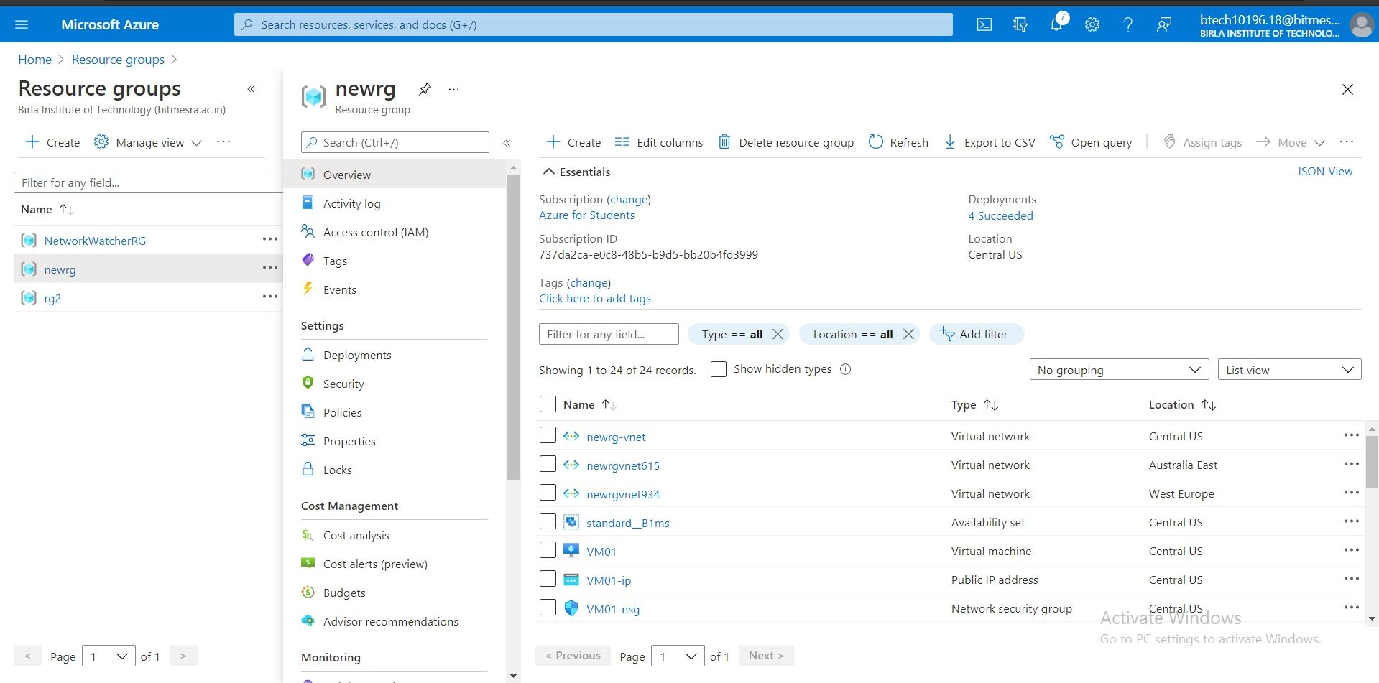

Go to the Locks section and click +add.

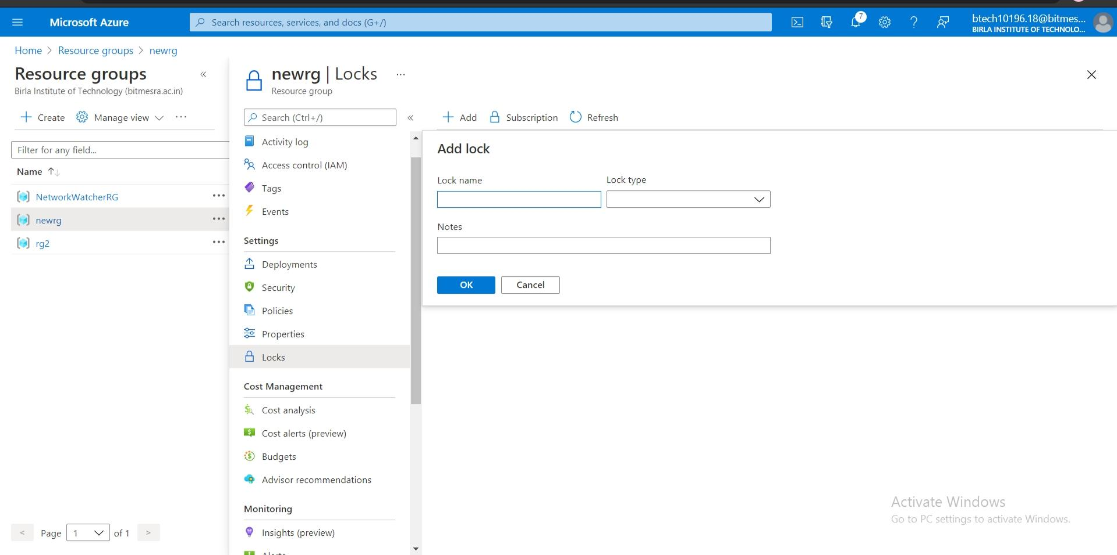

Select the details of the lock such as name,type and click add.

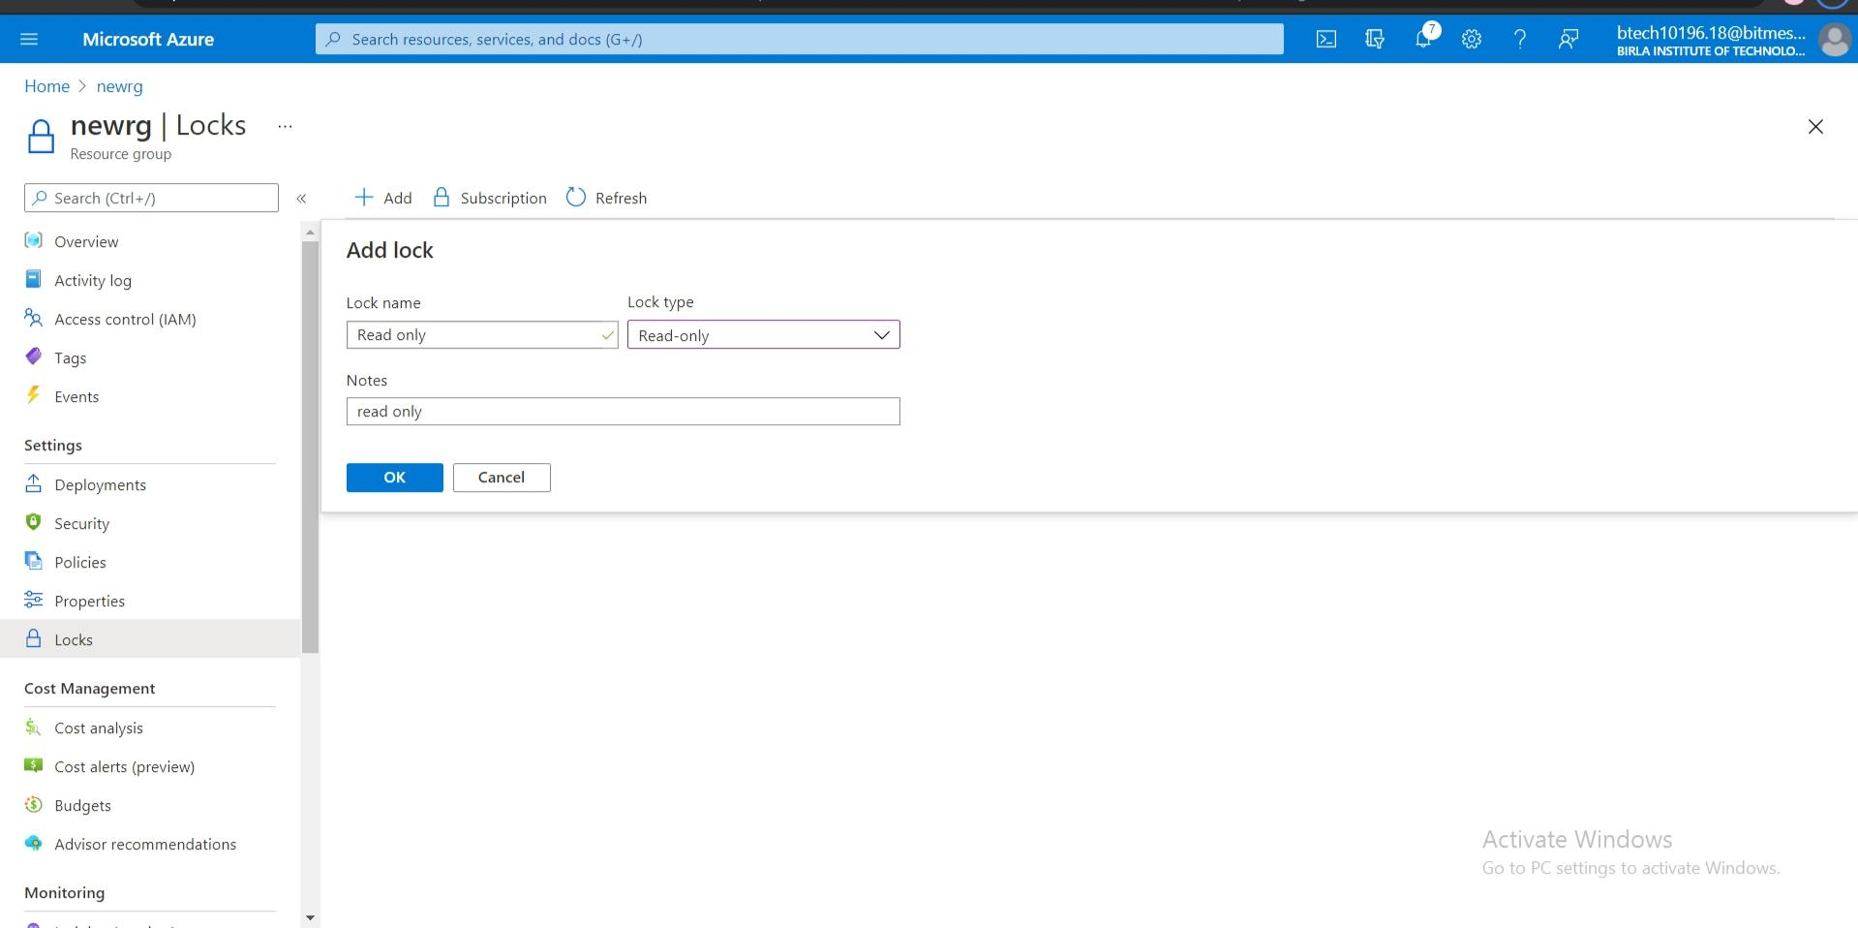

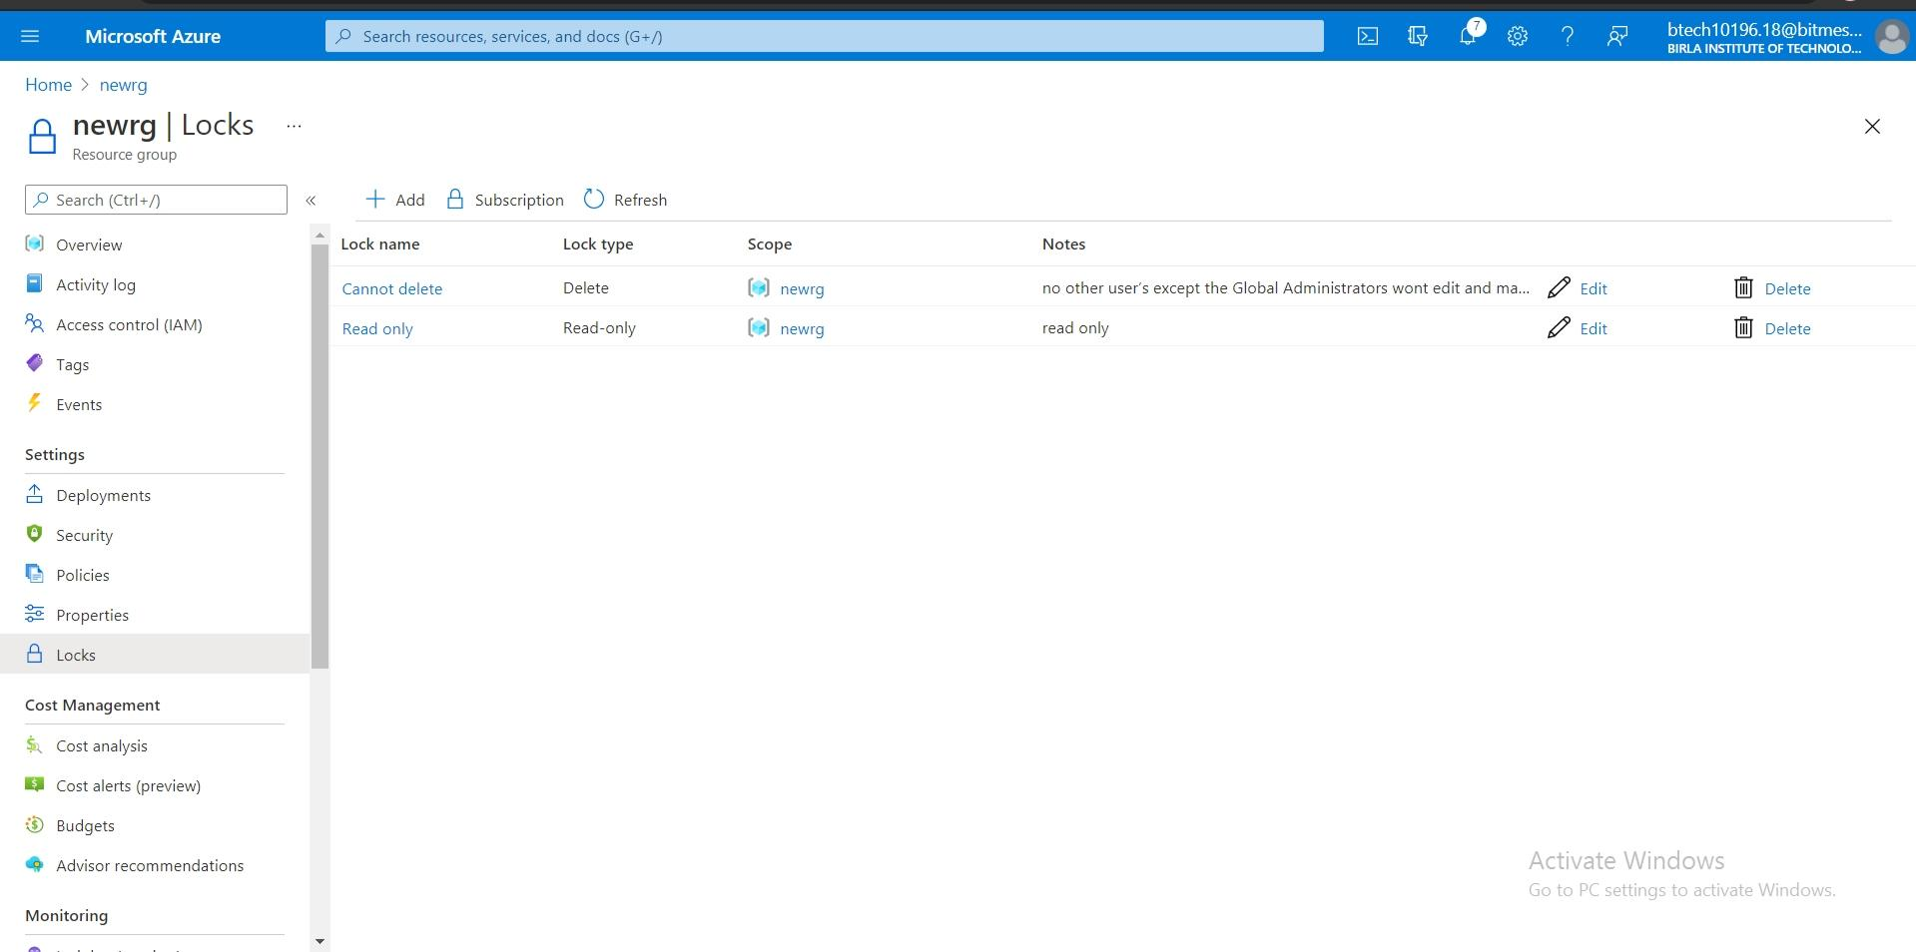

**8.Create Storage Account and Give access to the respective Client IP Address only.**

Go to Storage Accounts in Azure Portal and Click Create a Storage Account.

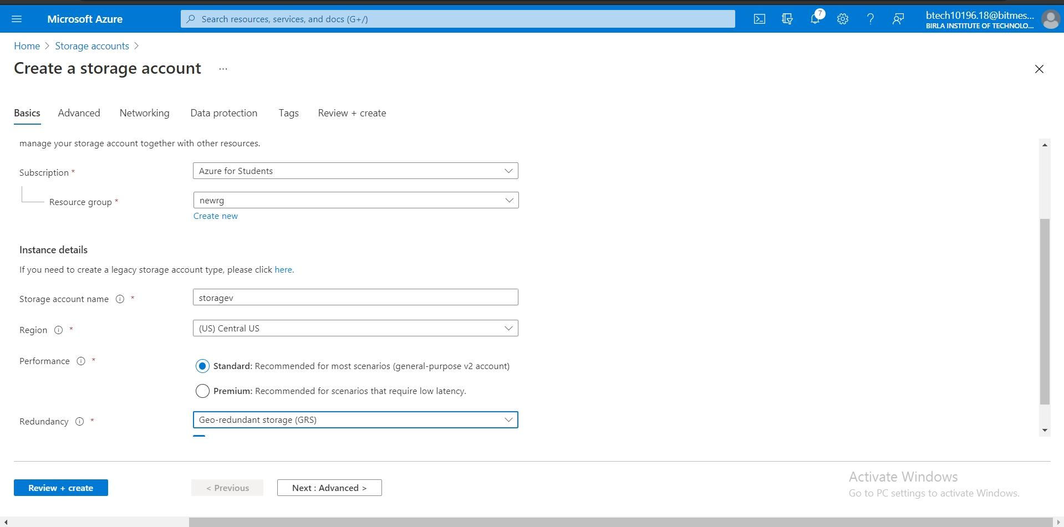

Fill the necessary details and click create.

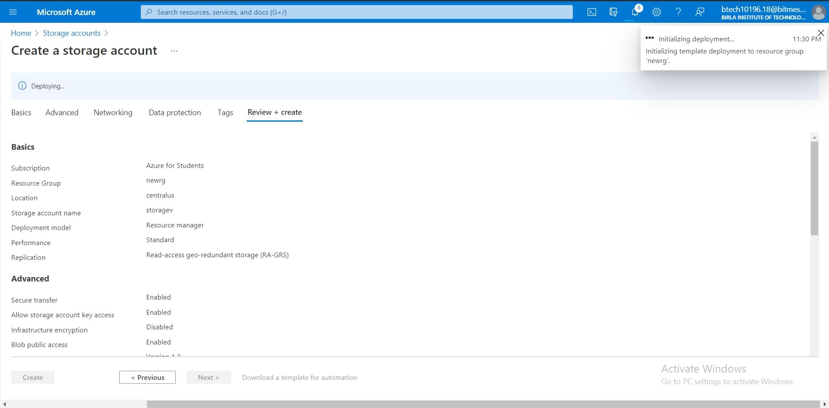

Wait for notification to show Deployment is complete.

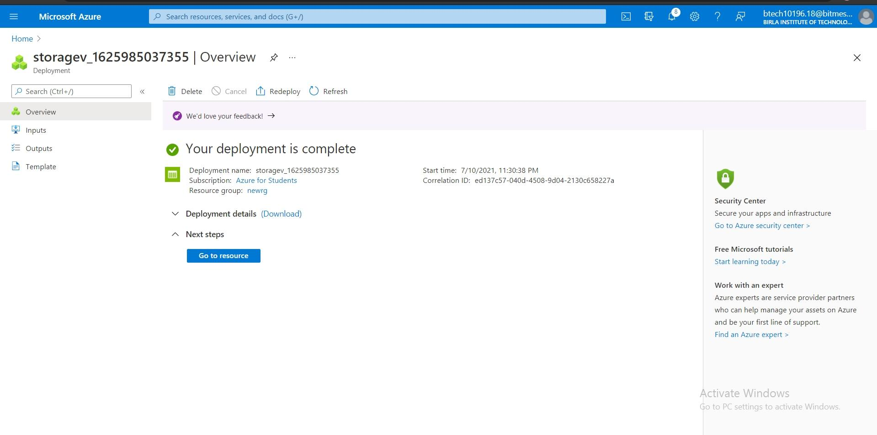

**9.Understand the Difference Between Availability Set and Zone.**

Availability Set-

An availability set is a logical grouping of VMs.By deploying at least two virtual machines into an availability set,we ensure that at least one of them remains available whenever planned or unplanned maintenance occurs.

Deploying VMs in an availability set will not protect an application from failures that are application-specific,it will provide protection against network outages, physical hardware failures, and power interruptions within an Azure data center.

Availability Zone-

An availability zone is a unique physical location that exists within a region.Every availability zone contains at least one data center within the region. Each of these data centers has its own infrastructure. Every enabled region in Azure consists of at least three separate zones that are physically separated so that it protects applications from data center failures.

Difference Between Availability Set and Availability Zone-

* Availability zones are similar in concept to availability sets. However, there is a distinct difference. While availability sets are used to protect applications from hardware failures within an Azure data center, availability zones protect applications from complete Azure data center failures.
* From the Service Level Agreement (SLA) standpoint, i.e uptime and connectivity - With Availability Set azure offers 99.95% SLA whereas with Availability Zone we have 99.99% SLA.

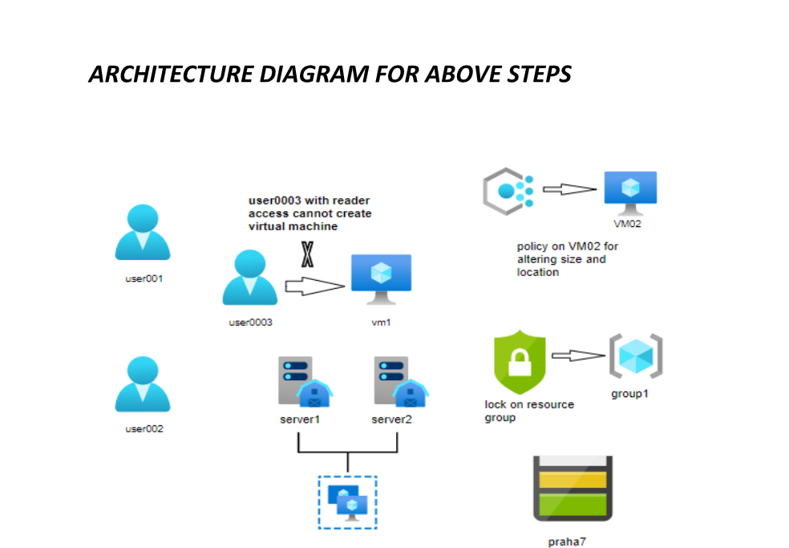

**Thankyou**